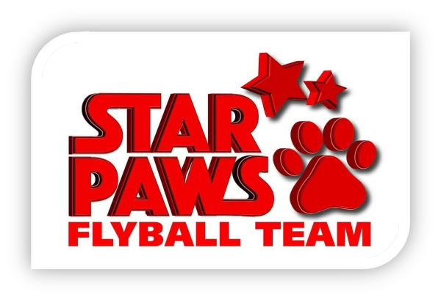

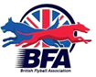
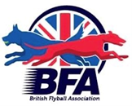

Star Paws Flyball Team

Present a British Flyball Association

LIMITED OPEN SANCTIONED TOURNAMENT (60 TEAMS)

&

Foundation Competition
On Saturday 18th & Sunday 19th February 2023

Closing date for all entries Saturday 14th January 2023

To be held at: The Strand, Kirkaldy, KY1 3LX

Racing will be Round Robin Block Format on Tuff Spun Matting Indoor

PLEASE NOTE: No entries can be accepted without payment

For further information contact Mandy Herald
6 Balcathie Farm Cottage, Arbroath, DD11 2PD
07885256758 starpawsflyball@outlook.com

Star Paws Flyball Team

Entry Form

LIMITED OPEN SANCTIONED TOURNAMENT
at The Strand, Kirkcaldy, KY1 3LX
On Saturday 18th and Sunday 19th February 2023
Closing date for entries Saturday 14th January 2023

Team Name/s | BFA Team Number
1
2
3
4
5

Declared times must be submitted in writing (or email) by 14th January 2023 and must be at least 0.25 faster or slower than seed time. Team break-out time is a quarter of a second faster than declared time. All times, seed or declared, except Div 1, are subject to the division break out rule.

FOUNDATION TOURNAMENT
Team Name/s | BFA Team Number
1
2
3
4

Team Captain
Name: | Address:
Captain BFA Number:
Telephone Number:
E-Mail address:

Judges
Judges availability (please tick appropriate box and supply name). | Provisional Judge | Qualified Judge | Head Judge | Measuring Official

Open Team Entry @ £45 per team |  | £
Foundation Team Entry @ £25 per team |  | £
Camping @ £8 per unit per night. | Number of units Friday | £
 | Number of units Saturday
 | Number of units Sunday
TOTAL PAYMENT |  | £

All Entries

Payment to Star Paws Flyball Team

Bank of Scotland Account number 17516867 Sort code 80-22-60

Complete and return to: Mandy Herald, 6 Balcathie Farm Cottage, Arbroath, DD11 2PD – starpawsflyball@outlook.com

Final running orders will be sent out approximately 1 week before the tournament.
NO ENTRIES WILL BE ACCEPTED WITHOUT PAYMENT

Show Rules and Regulations

1. The tournament organiser(s) reserve the right to refuse entries and admission to any person not in good standing with the B.F.A.
2. B.F.A. rules and policies will apply throughout the sanctioned tournament.
3. No person shall carry out punitive or harsh handling of a dog at the tournament.
4. It is the Team Captains responsibility to ensure the Team is available for its class and running order.
5. The organiser(s) reserve the right to make any alterations they deem necessary in the event of unforeseen circumstances.
6. Bitches in season are not allowed near the show area. Mating of dogs is not allowed.
7. A dog must be withdrawn from competition if it is:
a. Suffering from any infectious or contagious disease
b. A danger to safety of any person or animal
c. Likely to cause suffering to the dog if it continues to compete
8. All dogs enter into the tournament at their own risk and whilst every care will be taken, the organiser(s) cannot accept responsibility for damage, injury or loss however caused to dogs, persons or property whilst at the event.
9. All owners/handlers must clean up after their dogs. Anyone failing to do so will be asked to leave the venue.
10. No alcohol is to be consumed within or around the ring.
11. If circumstances make it necessary that the tournament is cancelled, the organisers reserve the right to defray expenses incurred by deducting such expenses from entry fees received.
Please be aware of the following rules that apply to this venue
12. NO BARBEQUES TO BE USED DIRECTLY ON THE GRASS MUST BE OFF THE GROUND
13. CAMPING SITES WILL BE ALLOCATED AND MUST BE KEPT TO FOR FIRE REGULATIONS

