present a

Sanctioned Competition

Limited Open Flyball Tournament (30 Teams)
at
Unit 3. Thistle Industrial Estate
Cowdenbeath
KY4 8LP

Sunday 21st October 2018
(closing date 20th Sept. 2018)

Featuring: Limited Open Classes (Block Format) and Starters

Paper entries to: Alan Wood, 9 The Logan, Liff, Dundee, Angus, DD2 5PJ
Email entries to: awood@taysideroadrunners.co.uk

Contact Alan Wood for further information/queries
Phone: 01382 580443 / 07968210975
Email: awood@taysideroadrunners.co.uk

Sunday 21st October 2018

Entry Form for BFA sanctioned Limited Open Tournament (30 Teams)
Entry Fee £45 per team

Declared times must be submitted in writing or email at least 14 days before the tournament & must be at least one second slower than seed time (BFA Rule 4.5).

N.B. Team break out time is half a second faster than declared time (5.17(l)). Declared times faster than the seed time are not subject to the team break out rule. All times, seed or declared, except Div 1, are subject to the division break out rule.

 | Team Name | Team BFA Number
1
2
3
4
5
6
7

Team Captain: | Name: | BFA no:
Address:
Tel No:
Email:

Entries accepted via e-mail to awood@taysideroadrunners.co.uk

Alternatively, please complete and return forms and payment via post - See over for Starters Entry, and Financial Information.

Sunday 21st October 2018
Starters Entry Form
Entry Fee £25 per Starters Team

Starters Team Name
1
2
3
4

Financial Information

Number of Open Teams entered |  | @ £45 per team | = £
Number of Starter Teams entered |  | @ £25 per team | = £
 |  | TOTAL | = £

Please return completed forms along with payment (cheque) to:
Alan Wood, 9 The Logan, Liff, Dundee, Angus, DD2 5PJ.

Cheques enclosed for £_________ (payable to Alan Wood)

Or email entries to awood@taysideroadrunners.co.uk

Payment can also be made via bank transfer (details below).

Bank Details: RBS Account no: 10190793
Sort code: 83-47-00

Please provide names of anyone who would be available to judge: Head Judge (HJ), Qualified Judge (QJ), Provisional Judge (PJ), Qualified Measurer (QM) or Provisional Measurer (PM):

Show Rules and Regulations

- The event organiser(s) reserve the right to refuse entries and admission to the event of any persons not in good standing within the BFA.
- No person shall carry out punitive or harsh handling of a dog at the event.
- Bitches in season are not allowed near the show area. Mating of dogs is not allowed.
- A dog must be withdrawn from competition if is:
  - Suffering from infectious or contagious diseases.
  - A danger to the safety of any person or animal.
  - Likely to cause suffering to the dog if it continues to compete
- It is the Team Captain’s responsibility to ensure the team is available for their division and running order
- The organiser(s) reserve the right to make any alterations they deem necessary in the event of unforeseen circumstances.
- All dogs enter the event at their own risk and whilst every care will be taken, the event organiser(s) cannot accept responsibility for damage, injury, or loss however caused to dogs, persons or property whilst at the event.
- All owners/handlers must clear up after their dogs. Anyone failing to do so will be asked to leave the venue.
- BFA rules and policies will apply throughout the Sanctioned Tournament.
- In the event of a 3-way tie, winner will be decided on times. In a 2-way tie, the winner is who beat who.
- This is an INDOOR tournament. In the event of the tournament being cancelled, the organiser(s) reserve the right to defray expenses incurred by deducting such expenses from the entry fees received.

THE TOURNAMENT WILL BE RUN ON 3G ASTRO TURF LAYED ON TOP OF 12mm CRUMB MATTING.

Directions to the venue

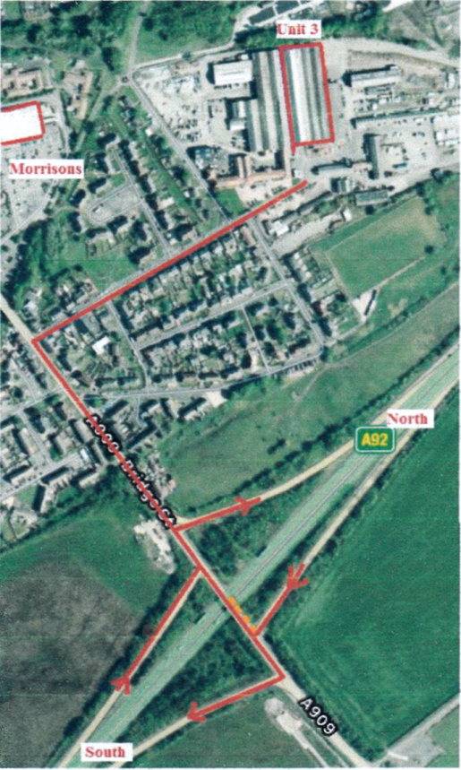

From North:

Join the A92 at Dundee. Head south on A92, and leave the A92 Cowdenbeath Junction. Turn right then after 100 yards take the 3rd right onto Church Street. Drive straight through the security gates over double speed bumps. Unit 3 is right in front of you as the road bends left (big roller shutter door).

From South:

Crossing the Forth Road Bridge (Queensferry Crossing), leave the M90 at junction 3 onto the A92. Take the first exit signposted Cowdenbeath. Turn left then take the 3rd right onto Church Street. Drive straight through the security gates over double speed bumps. Unit 3 is right in front of you as the road bends left (big roller shutter door).

CATERING WILL BE AVAILABLE ONSITE.

