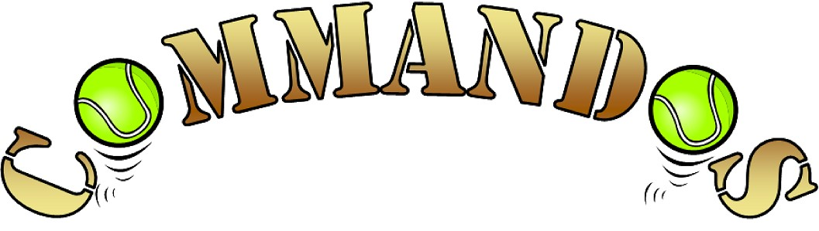
Flyball Teams
Present
Scorton
BRITISH FLYBALL ASSOCIATION
Sanctioned Limited Open Tournament
(30 Teams)

14th January 2023

At the

North Yorkshire Event Centre, Scorton, North Yorks, DL10 6EJ

Closing date for entries:

17th December 2022
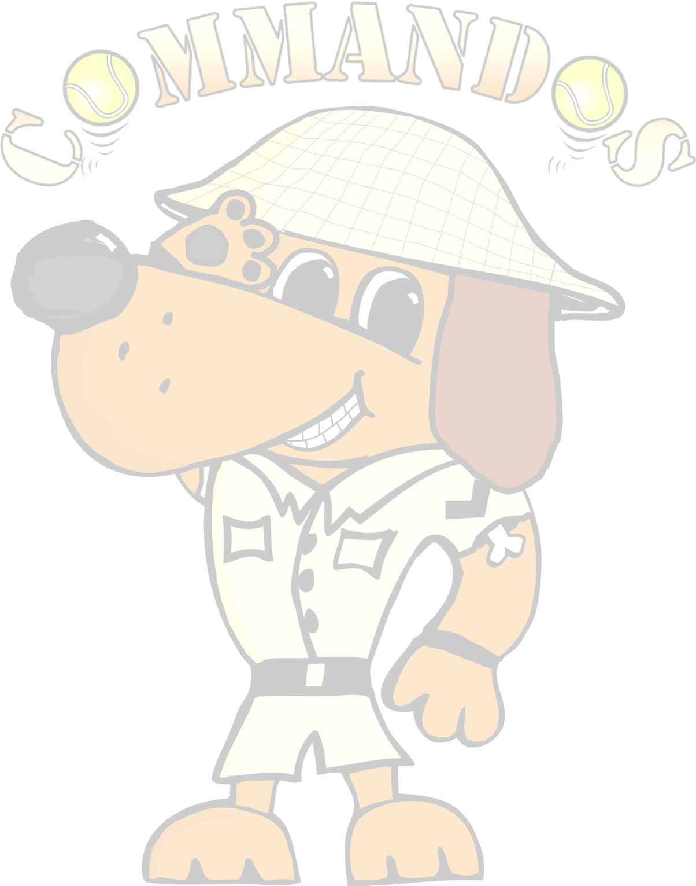
Event is block format held indoors on tuff spun matting.

Tournament Organiser
Janet Anderson
Golden Corner Cottage
Byers Green
Spennymoor
Co Durham
DL16 7QE
Tel: 07807746776 E-mail: commandosscortonentries@gmail.com

In order for your entry to be valid we require the Team Name, the TRN and the appropriate payment for each entry.

If we are over subscribed at the 24 hour stage only valid entries will be included in the draw.

Payment either by cheque with entry or by bank transfer.
Cheques Payable to Commandos Flyball Teams.

Sort Code: 30-98-13
Account Number: 29698968

Declared times must be submitted, in writing or email at least 14 days before the tournament and must be at least ½ a second slower or ½ second faster than seed time. (BFA rule A1: 4.3)

Team Break Out Time is 0.25 of a second faster then declared time (BFA rule A3: 11)

All times, seed or declared, except Division 1, are subject to the division breakout rule.

 | Team Name £50 per team | BFA Number
1
2
3
4
5
 | Total | £

Team Captain: |  | Address:
Tel No
Email:

Please name any members wanting to Judge or measure and if QJ, HJ, PMO

Tournament Rules and Regulations

Please note: Team Captains/Managers are responsible for ensuring that all members of their teams and accompanying party are informed of the rules and regulations pertaining to this tournament.

- The event organiser(s) reserve the right to refuse entries and admission to the event of any persons not in good standing within the BFA.

- No person shall carry out punitive or harsh handling of a dog at the event.

- Bitches in season are not allowed near the tournament area. Mating of dogs is not allowed.

- A dog must be withdrawn from competition if it is:
  - Suffering from infectious or contagious diseases.
  - A danger to the safety of any person or animal.
  - Likely to cause suffering to the dog if it continues to compete.

- It is the Team Captain’s responsibility to ensure the Team is available for their races.

- No person shall impugn the decision of the Head Judge(s) or Judges

- The organiser(s) reserve the right to make any alterations they deem necessary in the event of unforeseen circumstances.

- All dogs enter the event at their own risk and whilst every care will be taken, the Event Organiser (s) cannot accept responsibility for damage, injury or loss however caused to dogs, persons or property whilst at the event.

- All owners/handlers must clear up after their dogs and deposit waste in designated areas provided on site, to enable us to keep this venue for any further competitions. Anyone failing to do so will be asked to leave the venue.

- If circumstances make it necessary to cancel the tournament, the organisers
reserve the right to defray expenses incurred by deducting such expenses from the entry fees received

- BFA Rules and Policies operative at the closing date for entries will apply throughout the Sanctioned Tournament.

- All teams entering are expected to assist with Ring Party duties as requested by the Tournament Organiser

- No alcohol to be consumed within or around the ring

Any COVID restrictions that are put in place must be adhered to.

Directions

From North:
Leave A1 at junction 52, take third exit off roundabout, first exit off the next roundabout, first right towards Brompton on Swale, follow road to traffic lights, turn right to Scorton, follow the road through Scorton around the village green out the village towards Croft. The Events Centre is on the left about 1.5 miles out of the village.

From South:
Leave A1 at junction 52, take first exit off roundabout, first right towards Brompton on Swale, follow road to traffic lights, turn right to Scorton, follow the road through Scorton around the village green out the village towards Croft. The Events Centre is on the left about 1.5 miles out of the village.

