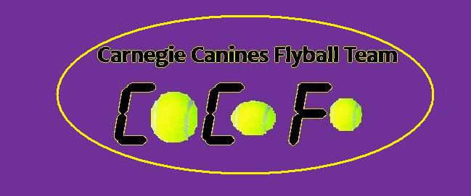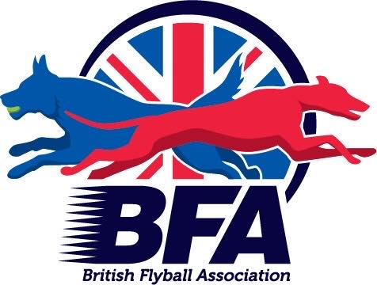
Fun Flyball Tournament
Pairs
&
Foundation
Saturday 10th September 2022
&
Sunday 11th September 2022
Closing Date: 26th July 2022

The Strand Building
Mitchelston Ind Est
Kirkcaldy
KY1 3LX

Entries to: Michelle Atkinson
92 Menteith Drive, Dunfermline Fife
KY11 8RS
Tel: 07522 922702
Email: matkinson694@googlemail.com

Show Rules and Regulations
- (1) The Event Organiser(s) reserve the right to refuse entries and admission to the event of any persons.
- (2) No person shall carry out punitive or harsh handling of a dog at the event.
- (3) Bitches in season are not allowed near the show area. Mating of dogs is not allowed.
- (4) A dog must be withdrawn from competition if it is:
- (a) Suffering from infectious or contagious diseases.
- (b) A danger to the safety of any person or animal.
- (c) Likely to cause suffering to the dog if it continues to compete.
- (5) It is the Teams Captain’s responsibility to ensure the team is available for their division and running order.
- (6) The organiser(s) reserve the right to make any alterations they deem
- necessary in the event of unforeseen circumstances.
- (7) All dogs enter the event at their own risk and whilst every care will be taken, the Event Organiser(s) cannot accept responsibility for damage, injury, or loss however caused to dogs, persons or property whilst at the event.
- (8) All owners/handlers must clear up after their dogs. Anyone failing to do so will be asked to leave the venue.
- (10) In the event of a 3 way tie winner will be decided on times. In a 2 way tie the winner is who beat who.
- (11)This is an INDOOR tournament, In the event of the tournament being cancelled, the organisers reserve the right to defray expenses incurred by deducting such expenses from the entry fees received
- THE TOURNAMENT WILL BE RUN ON 3G ASTRO TURF LAYED ON TOP OF 12MM CRUMB MATTING
- Further information or queries please contact:
- Michelle Atkinson
- Tel: 07522 922702
- Email: matkinson694@googlemail.com

Saturday 10th September 2022

- Entry Fee-£45.00 per Team
- Declared times should be submitted 14 days before the Tournament and must be at least 1/2 second faster or slower than seed time.
- Team break-out time is half a second faster than declared time
- All times, seed or declared, except Div 1, are subject to the division break-out rule.
Open Teams
- TEAM NAME
- 1:
- 2:
- 3:
- 4:
- 5:
- 6:

Foundation Team names
1:
2:
3:
4:

Team Captain:
Address:
Telephone:
Email:

- Name of anyone who is a Head Judge, Qualified Judge, Provisional Judge, Qualified Measurer
or Provisional Measurer (HJ, QJ, PJ, QM, PM):

Number of teams entered.......................at £45 per team
Total £...................
Payable to Carnegie Canines
Acc No: 11900764 Sort code: 80-22-60

Sunday 11th September 2022

- Entry Fee- Open team £45.00 per Team
- Declared times should be submitted 14 days before the Tournament and must be at least 1/2 second faster or slower than seed time.
- Team break-out time is half a second faster than declared time
- All times, seed or declared, except Div 1, are subject to the division break-out rule.

Open Team(s)
1:
2:
3:
4:
5:
6:

Foundation Team names
1:
2:
3:
4:

Team Captain:
Address:
Telephone:
Email:

- Name of anyone who is a Head Judge, Qualified Judge, Provisional Judge, Qualified Measurer
or Provisional Measurer (HJ, QJ, PJ, QM, PM):
Number of open teams entered.......................at £45 per team
Foundation teams entered…………. at £25 per team
Camping Pitches Total……………
Total £...................
Payable to Carnegie Canines
Acc No: 11900764 Sort code: 80-22-60

Camping Form

Pitches at £8.00 per night

Friday 9th September

Number of Caravans/Motorhomes/Camper vans:

Number of tents:

Saturday 10th September

Number of Caravans/Motorhomes/Camper vans:

Number of tents:

Sunday 11th September

Number of Caravans/Motorhomes/Camper vans:

Number of tents

