PRESENT
A 48 TEAM STARTERS AND INTERMEDIATE COMPETETION
Saturday 7th April 2018
Cherished Farm
Laverstoke Park
Southley Farm Cottages
Overton
Basingstoke
Hants
Closing date for entries 20th March 2018
For further information contact:
Erica Steele
Telephone: 07977 01 22 88
wickedflyballclub@gmail.com

Winners prizes will be sponsored by Nutriment Raw Food

Location and how to find us
Cherished Farm is only 5 minutes from junction 8 of the M3
https://goo.gl/maps/9ghQzrM97s62
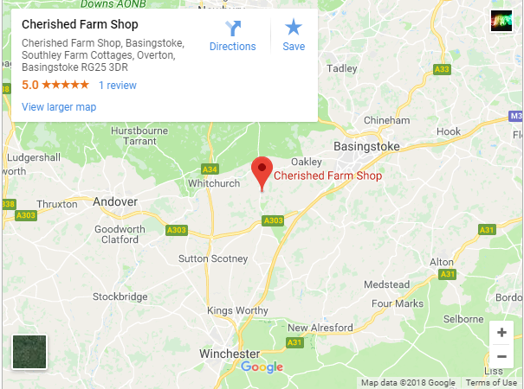
Refreshments
The Cherished Farm Coffee Shop will be open on the day and we are delighted to announce that they are offering a special deal for those attending the competition consisting of a jacket potato with either one or two toppings and a nice cup of tea for just £3.50 per head.
The toppings on offer will be chilli and cheese.
This offer will only be available by pre- order so please can you complete the Food Order Form, found below, and return this (together with payment) with your Competition Entry Form.
Cherished Farm Coffee Shop is owned by our sponsor Nutriment Raw Food and as such they will not only provide refreshment for us humans but they will also have a great range of lovely Nutriment Raw food and treats on offer for your dogs to enjoy.
Food Order Form
Club Name:
Total Number to order at £3.50 per head:
Total payment submitted in advance:
Cheques made payable to Wicked Flyball Club
Team captains can pick up their teams’ food vouchers from the Administration Tent on the day.

ENTRY FORM- Starters and Intermediates
In the interests of fair competition, we are asking that you submit declared times for each of your teams if possible on entry but in any case, no later than 14 days in advance of the tournament.
Email entries to: wickedflyballclub@gmail.com
 | Team Name | Team Number | Starters/ Intermediate  (Please select) | Declared time
1) |  |  | S / I
2) |  |  | S / I
3) |  |  | S / I
4) |  |  | S / I
5) |  |  | S / I
6) |  |  | S / I
7) |  |  | S / I
Postal entries: Erica Steele, 2 Marlborough Gardens, Oakley, Basingstoke,
Hampshire, RG23 7AH
Team Captain
Telephone
E-mail
Address
Teams entered: at £30.00 per team. Total cost: £
Cheque payments to be made out to Wicked Flyball Club and submitted with entry. Should you wish to pay by bank transfer please contact Erica for details.
Qualified Judges:
Provisional Judges:
Show Regulations:
- Current BFA Rules and Policies to apply throughout the tournament.
- In the interest of good competition, we would like declared times from each team, however no divisional breakouts will be applied.
- The event organisers reserve the right to refuse entries and admission to the event of any person not in good standing within the BFA.
- No person shall carry out punitive or harsh handling of any dog.
- Bitches in season are not allowed near the tournament area.
- Mating of dogs is not allowed.
- Any bitch due to whelp within 7 days of the competitions is not permitted at the tournament.
- No bitch can compete whilst in pup and for at least eight weeks after giving birth.
- A dog must be withdrawn from the competition if it is suffering from an infectious or contagious disease, is a danger to the safety of any person or animal or if it is likely to cause suffering to the dog if it continues to compete.
- It is the Team Captain’s responsibility to ensure their team is available for their division.
- The organiser along with the Head Judge reserves the right to make necessary alterations in the event of unforeseen circumstances.
- If circumstances make it necessary to cancel the tournament, the organisers have the right to defray expenses incurred by deducting such expenses from the entry fees received.
- All dogs enter the event at their own risk. Every care will be taken to ensure the safety of the dogs and competitors, but the tournament organiser cannot accept responsibility for damage, injury or loss caused to dogs or persons at the event.
- Competitors must pick up after their dogs. Anyone failing to do so will be asked to leave the venue.
- A two-way tie will be decided by who beat who, a three- way tie will be decided on fastest time.

