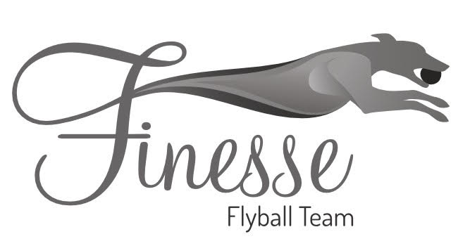

Finesse Flyball Teams Presents
British Flyball Association
2 x 1 day Sanctioned Limited Open Tournaments
(30 Teams)

Saturday 18th March 2023
(Staggered format)
&
Sunday 19th March 2023
(Block format)

At
Culcheth High School
Warrington Road
Culcheth
Warrington
Cheshire
WA3 5HH

Closing date for entries
Sunday 26th February 2022

Please follow the following link for entry form:
https://forms.gle/zZmJB4RKkYsFKPt99

