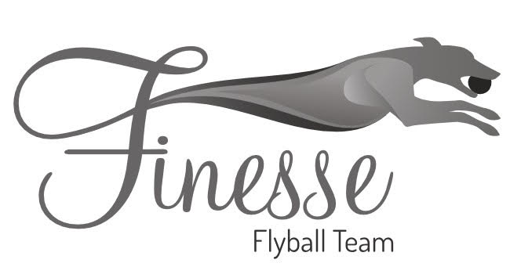

Finesse Flyball Team presents
British Flyball Association
2 x 1 day Sanctioned Limited Open Tournaments
(30 Teams)
Indoor TuffSpun

Saturday 24th February 2024 (RR Staggered format)
&
Sunday 25th March 2024 (RR Block format)

At
Culcheth High School
Warrington Road
Culcheth
Warrington
Cheshire
WA3 5HH

Closing date for entries
Friday 26th January 2024

Please follow the following link for entry form:
https://forms.gle/yMdjVR7g4pLfSV9s5

Please send any queries/declared times to
Louise McInulty at finesseflyballteams@gmail.com

