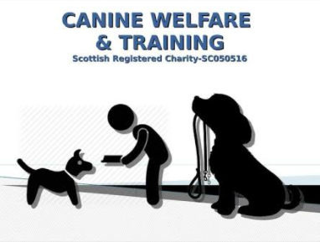
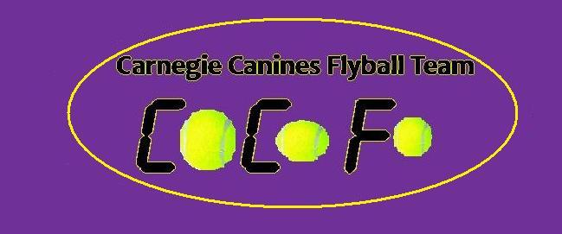

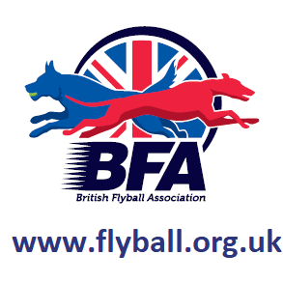

Sanctioned
Limited Open Tournament
(30 teams)
(5 Team Foundation Flyball Div)

Saturday 31st July & Sunday 1st August 2021

The Strand Building
Kirkcaldy
Fife
KY1 3LX

Entries to: Katie McPhail
Tel: 07866561386
Email: caitlinmcphail29@gmail.com

Show Rules and Regulations
- (1) The Event Organiser(s) reserve the right to refuse entries and admission to the event of any persons not in good standing within the BFA.
- (2) No person shall carry out punitive or harsh handling of a dog at the event.
- (3) Bitches in season are not allowed near the show area. Mating of dogs is not allowed.
- (4) A dog must be withdrawn from competition if it is:
- (a) Suffering from infectious or contagious diseases.
- (b) A danger to the safety of any person or animal.
- (c) Likely to cause suffering to the dog if it continues to compete.
- (5) It is the Teams Captain’s responsibility to ensure the team is available for their division and running order.
- (6) The organiser(s) reserve the right to make any alterations they deem
- necessary in the event of unforeseen circumstances.
- (7) All dogs enter the event at their own risk and whilst every care will be taken, the Event Organiser(s) cannot accept responsibility for damage, injury, or loss however caused to dogs, persons or property whilst at the event.
- (8) All owners/handlers must clear up after their dogs. Anyone failing to do so will be asked to leave the venue.
- (9) BFA Rules and Policies will apply throughout the Sanctioned Tournament.
- (10) In the event of a 3-way tie winner will be decided on times. In a 2 way tie the winner is who beat who.
- (11) This is an OUTDOOR tournament, In the event of the tournament being cancelled, the organisers reserve the right to defray expenses incurred by deducting such expenses from the entry fees received
- THE TOURNAMENT WILL BE RUN ON GRASS.
- Further information or queries please contact:

- Michelle Atkinson
- Tel: 07522 922702
- Email: matkinson694@googlemail.com

- Katie McPhail
- Tel: 07866561386
- Email: caitlinmcphail29@gmail.com

Saturday 31st July and Sunday 1st August 2021

- Entry Fee
  - Open £45 per Team
  - Foundation Flyball £25 per Team
- 14 days before the Tournament and must be at least 1/2 second slower than seed time. (BFA rule 4.5)
- Team break-out time is quarter of a second faster than declared time (5.17(l))
- All times, seed or declared, except Div. 1, are subject to the division break-out rule.

- TEAM NAME BFA No.
- 1
- 2:
- 3:
- 4:
- 5:
- 6:
- Foundation Flyball Team Name(s)

- Team Captain :
- BFA No:
- Address :
- Telephone :
- Email :

- Name of anyone who is a Head Judge, Qualified Judge, Provisional Judge, Qualified Measurer or Provisional Measurer (HJ, QJ, PJ, QM, PM):

- Number of dogs to be measured:
  - Time slots - TBC
- Number of Teams entered at £45 per team:
- Foundation Flyball Teams entered at £25 per team:
  - Please ensure all non-BFA members pre-register and receive FF code.
- Camping Pitches required at £8 per pitch per night – please state:
  - Tent:
  - Caravan – no awning:
  - Caravan – with awning:
- Total £

Cheques payable to Carnegie Canines
- Carnegie Canines Acc No: 11900764
- Sort code: 80-22-60

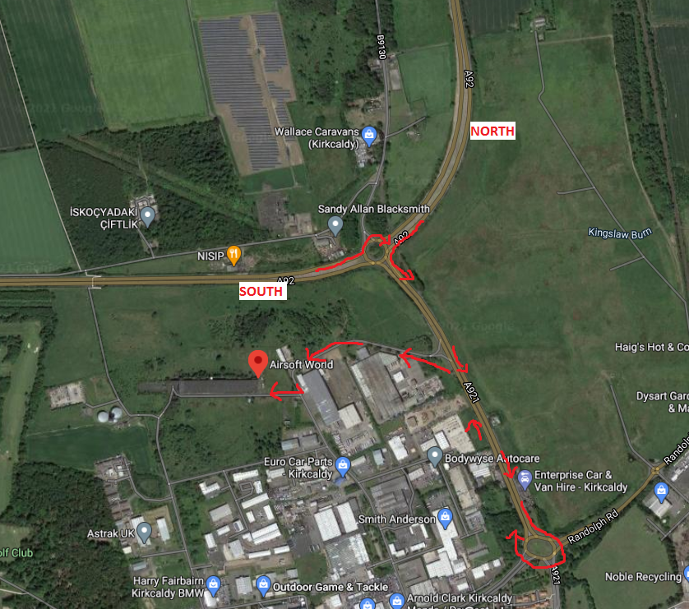

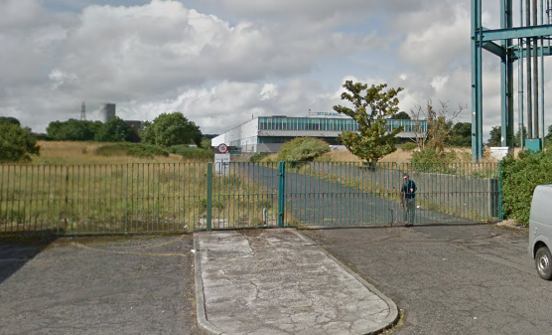

Directions

From North

Join A92 at Dundee and head south on A92. Leave A92 at Redhouse Roundabout following signs for Kirkcaldy East/Central, first exit from Redhouse Roundabout. Follow the dual carriageway, A921 to the next roundabout and leave at 4th exit and re-join A921 in the opposite direction. After the Garden Centre on your left and before re-joining Redhouse Roundabout, take the slip road to your left onto Mitchelston Drive into the Industrial Estate. Follow this road around, shortly after the left bend, take the next right and follow the road through the green, metal gates pictured above. Venue is on the right-hand side.

From South

Crossing the Queensferry Crossing, remain on M90 and leave at Junction 2A onto A92, signposted Kirkcaldy/Glenrothes. Remain on A92 and leave at Redhouse Roundabout, following signs for Kirkcaldy East/Central, 3rd exit from Redhouse Roundabout. Follow the dual carriageway, A921 to the next roundabout and leave at 4th exit and re-join A921 in the opposite direction. After the Garden Centre on your left and before re-joining Redhouse Roundabout, take the slip road to your left onto Mitchelston Drive into the Industrial Estate. Follow this road around, shortly after the left bend, take the next right and follow the road through the green, metal gates pictured above. Venue is on the right-hand side.

*Please note, there is Deer on site*

