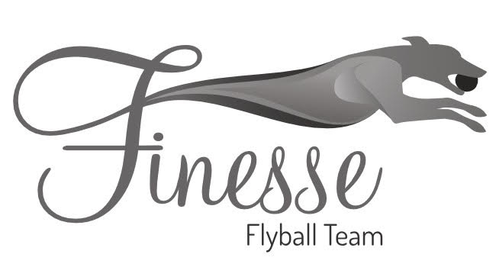

Finesse Flyball Teams Presents
British Flyball Association
Sanctioned Limited Open Tournament
(30 Teams)

Saturday 25th February 2023

At
Deeside Leisure Centre
Chester Road West
Queensferry
Deeside
CH5 1SA

Closing date for entries
Friday 27th January 2022

Please follow the following link for entry form: https://forms.gle/2Y6KM55kpdVtMw7z7

