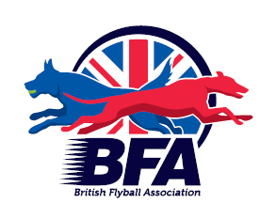
Flyball Teams
Present
BRITISH FLYBALL ASSOCIATION
Sanctioned Limited
Open Tournament
(30 Teams)
Sat 8th February 2020
at
North Yorkshire Events Centre
Scorton, North Yorkshire
DL10 6EJ

Closing date for entries:
11th January 2020

Event is block format held indoors on tuff spun matting

Email entries to: commandosscortonentries@gmail.com

Or sent to:
Tournament Organiser
Leanne Hyde
Sycamore Cottage
Low Hall Lane
Scotton
DL93PL
Tel: 07834181637
Payment either by cheque with entry or by bank transfer before closing date.
Cheques Payable to Commandos Flyball Teams.
Sort Code: 30-98-13
Account Number: 29698968

Limited Open Sanctioned Tournament (30)
Declared times must be submitted in writing (or email) at least 14 days before the tournament & must be at least ½ faster or ½ second slower than seed time. (BFA Rule 4.3)
N.B. Team break-out time is half a second faster than declared time. (BFA Rules of Racing A.3 (11))

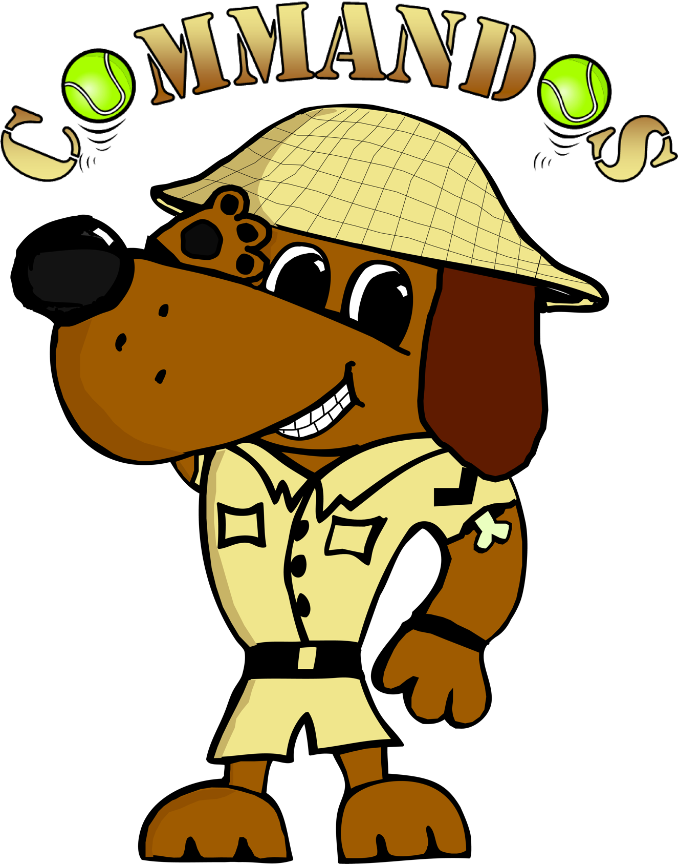

 | Team Name | BFA Number
1
2
3
4
5
6
7
8

Team Captain: | BFA Number:
Tel No:
Email:

Please name any members wanting to Judge and if QJ, HJ, & Measuring Officials

Number of teams……………….. @£45 per team
Total payable £………..

Tournament Rules and Regulations

1) The event organiser(s) reserve the right to refuse entries and admission to the event of any persons not in good standing within the BFA.

2) No person shall carry out punitive or harsh handling of a dog at the event.

3) Bitches in season are not allowed near the tournament area. Mating of dogs
is not allowed.

4) A dog must be withdrawn from competition if it is:
a) Suffering from infectious or contagious diseases.
b) A danger to the safety of any person or animal.
c) Likely to cause suffering to the dog if it continues to compete.

5) It is the Team Captain’s responsibility to ensure the Team is available for their
division and recording of running order.

6) The organiser(s) reserve the right to make any alterations they deem
necessary in the event of unforeseen circumstances.

7) All dogs enter the event at their own risk and whilst every care will be taken,
the Event Organiser (s) cannot accept responsibility for damage, injury or loss
how ever caused to dogs, persons or property whilst at the event.

8) All owners/handlers must clear up after their dogs and deposit waste in
designated areas provided on site, to enable us to keep this venue for any
further competitions. Anyone failing to do so will be asked to leave the venue.

9) If circumstances make it necessary to cancel the tournament, the organisers reserve the right to defray expenses incurred by deducting such expenses from the entry fees received

10) BFA Rules and Policies operative at the closing date for entries will apply
throughout the Sanctioned Tournament.

Site Map – please do not enter any of the farm fields. We have no access to these.

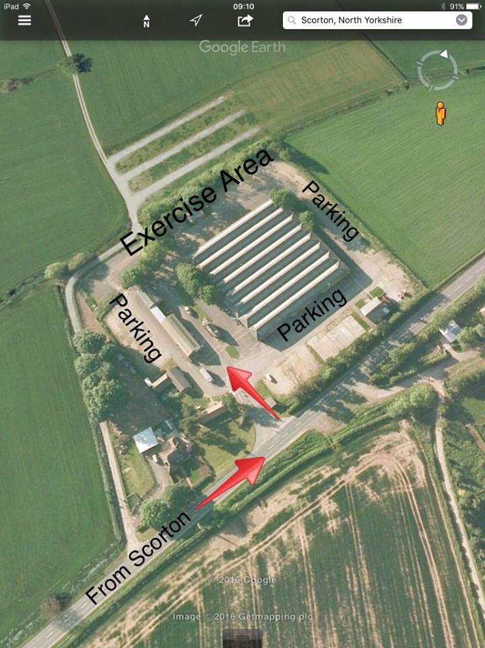

- Bert the person who over sees the Events Centre has a café inside the building that again will be serving hot snacks and drinks.
Directions
From the North
- A1 Southbound take the next exit after Scotch Corner sign posted Brompton on Swale only (Local traffic only) Yellow sign and still in roadworks!!
- At the traffic lights turn left towards Scorton. Follow this road into the village.
- Follow the village green round to the right with the Farmers arms pub on the left then leave the village straight ahead. Cross over a small bridge as you leave the village.
- The Events centre is about 1.5 miles outside the village on the LEFT hand side (SAT navs will tell you it’s on the right this takes you to some lovely persons house who would rather not have 7am visitors!!!!

From the South – DO NOT FOLLOW SAT NAVS UNTIL YOU ARE IN CATTERICK VILLAGE
The new junction is now fully open!
- Take junction 52 sign posted Catterick.
- Top of the slip road take the 3rd exit on the roundabout towards Catterick and Marne Barracks.
- Next Roundabout 1st Exit (This is straight across) Sign posted Catterick and Marne Barracks
- First Left Sign posted Scorton, Catterick
- Follow this road all the way through Catterick Village, stay on this road past the race course and bear right over Catterick bridge (Passing a hotel with scaffolding up on the right before the bridge)
- At the crossroad traffic lights turn right to Scorton. Follow this road to the village.
- Follow the village green round to the right with the Farmers arms pub on the left then leave the village straight ahead. Cross over a small bridge as you leave the village.
- The Events centre is about 1.5 miles outside the village on the LEFT hand side (SAT navs will tell you it’s on the right this takes you to some lovely persons house who would rather not have 7am visitors!!!!

