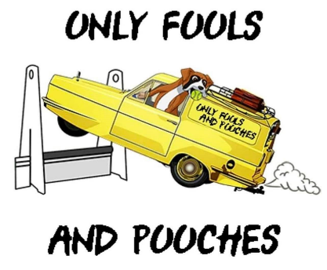
Only Fools & Pooches British Flyball Association Sanctioned Tournament

Limited Open Tournament (54 Teams)
Plus 1 Foundation Division
Additional Foundation will be made available if entry allows

Over two days - Saturday 13th & Sunday 14th May 2023
(Closing Date – Friday 21st April 2023)

Venue
Brookfield Farm
Sproston Green, Holmes Chapel
Cheshire
CW4 7LN
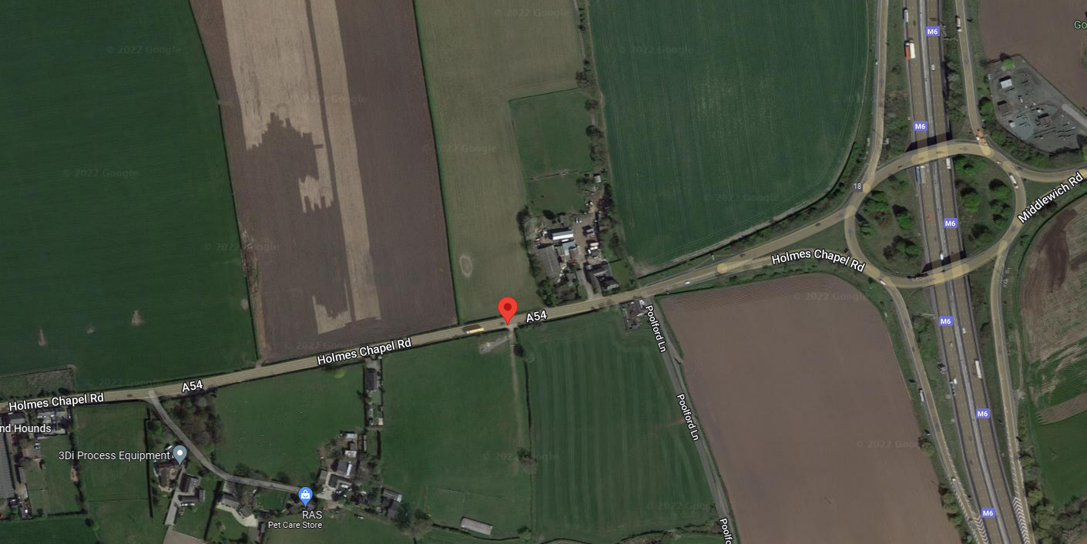
Approx 200 yards afters Junction 18 M6 roundabout on A54 towards Middlewich

53°11'58.1"N 2°23'36.4"W

53.199470, -2.393447

SHOW RULES AND REGULATIONS
1. The event organisers reserve the right to refuse entries and admission to any person not in good standing with the BFA.
2. It is the Team Captain’s responsibility to ensure that the team is available for its division and running order.
3. No person shall dispute the decisions of the Head Judge or Judges.
4. The organisers reserve the right to make any alterations they deem necessary in the event of unforeseen circumstances.
5. All dogs are entered in this event at their owners’ risk and whilst every care will be taken, the event organisers cannot accept responsibility for damage, injury or loss, however caused, to dogs, persons or property whilst at the event.
6. All owners/handlers must clean up after their dogs. Anyone failing to do so will be asked to leave the venue.
7. If circumstances make it necessary for the tournament to be cancelled, the organisers reserve the right to defray expenses incurred by deducting such expenses from entry fees received.
8. No person shall carry out punitive or harsh handling of a dog at the event.
9. Bitches in season are not allowed near the show area. Mating of dogs is not allowed.

10. A dog must be withdrawn from competition if it is:

(a) Suffering from infectious/contagious diseases and, in the case of kennel cough, it has not been free of symptoms for a minimum of 21 days.

(b) A danger to the safety of any person or animal.

(c) Likely to cause suffering to the dog if it continues to compete.

11. In the event of a 3-way tie, the winner will be decided on times. In a 2-way tie the winner is who beat whom.

12. A two minute warm up period will apply.

In order that we remain in good standing with our hosts ‘Brookfield Farm’ please be aware of the following;
13. All competitors and visitors are requested to practise good ‘housekeeping’ on the grounds to keep these areas free of litter and fouling.
14. There will be a sign posted area for dog walking. Dogs must be kept on lead until they reach the area. Leads must be used when in the camping areas and in the vicinity of the rings.
15. There is a strict 5mph on site.
16. As the farm boarders private property, please give consideration to neighbouring properties.

ONLY FOOLS & POOCHES ENTRY FORM

WE WOULD PREFER YOU TO USE GOOGLE FORMS - HERE IS THE LINK

https://forms.gle/Yx4K5Ti2HfWiFyZi6

Entry Form for BFA Sanctioned Limited Open Tournament
(Limited to 54 Open Teams and 1 Foundation Division)
Brookfield Farm, Sproston Green, Holmes Chapel, Cheshire, CW4 7LN
Saturday 13th & Sunday 14th May 2023
(Closing Date – Friday 21st April 2023)
Entry Fee £45 per Open Team & £30 per Foundation Team

Declared times must be submitted by email at least 14 days before the tournament and must be at least half a second faster or slower than the teams seeded time. (BFA rule A1 4.3)
Team breakout time is ¼ of a second faster than declared time or ¼ of a second faster than the divisional breakout time (except Division 1) all as defined by BFA rule A3 11.

TEAMS

 | Open Team Name | Team BFA Number
1
2
3
4
5
6
 | Foundation Team Name
1
2
3

CAMPING

Camping Fee is £12.50 per night or £30 for 3 nights. No arrival before 12.00 on Fri. Departures by 12.00 Mon please.

NUMBER OF UNITS
FRIDAY NIGHT | SATURDAY NIGHT | SUNDAY NIGHT | FULL WEEKEND

COST SUMMARY

ITEM | NUMBER | COST
OPEN TEAMS X £45
STARTER TEAMS X £30
CAMPING NIGHTS X £12.50
CAMPING WEEKEND X £30
 | TOTAL FEE DUE

Payments by bank transfer may be made to the following account:-

Payments by bank transfer may be made to the following account:-

Bank – Santander
Account Name – Only Fools & Pooches
Sort Code – 09-01-29
Account Number – 30574937

ENTRIES WILL NOT BE ACCEPTED WITHOUT PAYMENT

CLUB CAPTAIN DETAILS

Name
Address
Tel. Number
Email
HEAD JUDGE/JUDGE/PROVISIONAL JUDGE/MEASURING OFFICIAL

If you are able to provide any of the above please supply details …

Name | Qualification(s) | BFA Number

Please tick the box if you are able to provide a Ring Party

POSTAL ENTRIES

Please send your completed entry form to:-

Jemma Dakin-Brown,
27 Chesterfield Close,
Winsford
Cheshire
CW7 2NS

E-MAIL ENTRIES

Please send to ofpcomps@gmail.com and attach your completed entry form.

FURTHER INFORMATION

Please contact Paul Astbury:-
Tel 0151 431 1607
Mob 07877 199227
E-mail ofpcomps@gmail.com

