PRESENTS
A 96 TEAM BRITISH FLYBALL SANTIONED TOURNAMENT
AT
Mapledurham House
Reading, Berkshire
RG4 7TR
Event details:
Friday 2nd July Singles, Pairs & Ogilvie Workshop
Saturday 3rd & Sunday 4th July 2021 Limited Open Tournament
(Closing date for entries 7th June 2021)
Head Judge: Justin Shearing
For further information contact:
Erica Steele
Telephone: 07977 01 22 88
E-mail: wickedflyballclub@gmail.com
Please email entries to the above email address and confirmation email will be sent.
Online Entry
Please click on the link to enter using our online form and a conformation email will be sent.
https://docs.google.com/forms/d/e/1FAIpQLSeDdQhvbGxi7w1YxVAnLcRiWfIwnxHE8dF5kxVQwxtP4wrZOw/viewform?vc=0&c=0&w=1&flr=0&gxids=7628
Camping available from 12:00 on Friday 2nd 2021. Camping must be booked in advance. Camping will be marked out, and you will be directed to your area upon arrival. We cannot guarantee we can accommodate late bookings.
Important information- This is just a general booking.
Further guidelines may be issued before the show to reflect the current government rules and guidance.

Entry form for limited open BFA sanctioned tournament
Saturday 3rd and Sunday 4th July 2021
Declared times must be submitted in writing (or email) at least 14 days before the Tournament and must be at least a half second slower or faster than seed time. (BFA rule 4.4) Team break out time is half a second faster than declared time (5.17(I)). All times, seed or declared with the exception of Division One, are subject to the Division breakout rule.
ENTRY FORM- Limited open Tournament
Team Name | Team Number | Declared Y/N
1.
2.
3.
4.
5.
6.
ENTRY FORM – Limited Singles/Pairs
Please note that running each of the following categories is subject to entry levels.
Singles: (£5.00 per entry)
Dog Name | Dog Name
Pairs: (£10.00 per pairs entry)
Dog Name | Dog Name

Team Captain’s Name:
Telephone number:
Email:

Please could you provide names of people who would like to be judge, provisional judge or Height measurer?
Height Measuring. There is a possibility that we will have lots of dogs that need measuring. Therefore, we would like to get numbers so we can see if we would need to open a measuring station on Friday and Saturday night, so racing is not delayed in the morning. Could you please provide me with how many dogs in your team need measuring?
Judge
Provisional Judge
Height Measurer
Dogs Need to measure
Camping pitches required at £10 per night per pitch for Friday and Saturday night only.
Friday Night |  | £
Saturday Night |  | £
Total |  | £
Bank details sort code: 30-65-65 Account number: 50242868
Please put team name as reference (Entries will not be accepted without payment)
Starters
If we are able to provide a division of foundation/singles/pairs would you be interested in entering a team? YES/NO
Location how to find us
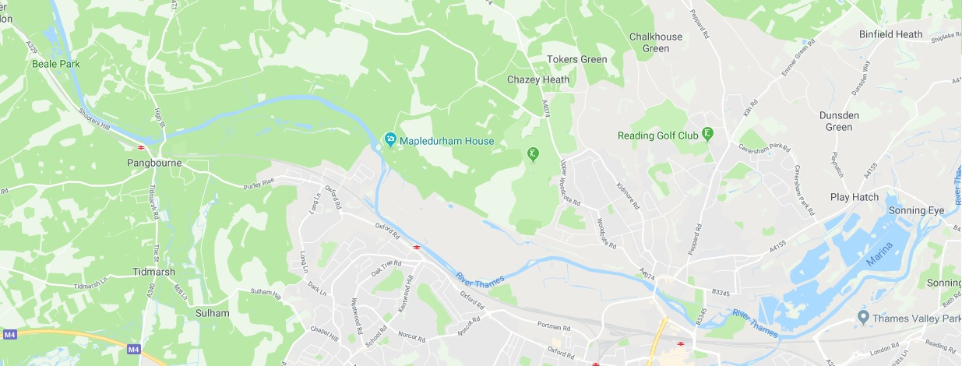
Refreshments
We have a food van arriving Saturday will be there over the whole weekend providing food, drinks, and ice creams.
Entertainment
Wicked will be providing entertainment on Saturday night with a fabulous sport day event, we would like to invite you to join us for a fun filled evening. This will all be subject to government rules and will be ran in a covid safe way. More details to follow.
River Thames
Please be aware the river Thames runs along side the venue. We would like to make sure you keep an eye on all you children and have a suitable adult looking after them and take responsibility of them.
Arriving details
You will not be able to gain access to Mapledurham estate until midday on Friday 2nd July, If you arrive early you will not be allowed to enter and will cause traffic issues on road outside. So please be aware of what time you head to Mapledurham. Gates will be closed during quiet times and a gate code will be provided to all Team captains from midday on 2nd July.
We look forward to seeing you in July
Wicked Flyball Club

Tournament Rules and Regulations
Requests for specific days
We will try to accommodate requests for specific days from teams, however this cannot be guaranteed. It is difficult to consider any requests until the running orders have been completed, 2 weeks prior to the event.
Sadly, refunds will not be issued if we are unable to accommodate your request and you withdraw beyond the competition closing date.
(1) The Event Organizer(s) reserve the right to refuse entries and admission to the event of any persons not in good standing within the BFA.
(2) No person shall carry out punitive or harsh handling of a dog at the event.
(3) Bitches in season are not allowed near the show area. Mating of dogs is not allowed.
(4) A dog must be withdrawn from competition if it is:
(a) Suffering from infectious or contagious diseases.
(b) A danger to the safety of any person or animal.
(c) Likely to cause suffering to the dog if it continues to compete.
(5) It is the Teams Captain’s responsibility to ensure the team is available for their division and running order.
(6) The organizer(s) reserve the right to make any alterations they deem necessary in the event of unforeseen circumstances.
(7) All dogs enter the event at their own risk and whilst every care will be taken, the Event Organizer(s) cannot accept responsibility for damage, injury, or loss however caused to dogs, persons or property whilst at the event.
(8) All owners/handlers must clear up after their dogs. Anyone failing to do so will be asked to leave the venue.
(9) Current BFA Rules and Policies will apply throughout the Sanctioned Tournament
(10) If circumstances make it necessary to cancel the tournament, the organisers reserve the right to defray expenses incurred
Please be aware of the following rules that apply to this venue.
(11) All competitors MUST obey any “out of bounds” or restricted areas that are in place.
No ground level BBQs are allowed or fires/firepits.

(12) All competitors and visitors are responsible for their dogs and must make every effort to ensure they do not cause noise nuisance when not racing (or waiting to race) to the equestrian centre surrounding the venue and visitors to Mapledurham Estate.
(13) Camping is ready marked from each team, please be considerate when setting up and that you stay within your area.
(a) All camping must be booked in advance and paid for.
(b) Wicked may not be able to accommodate camping at short notice
(14) All vehicles should keep to 5mph on the venue. Please keep driving during the tournament to
a minimum.
(15) Please ensure generators are switched off between 11pm and 7am.
IT IS THE TEAM CAPTAINS RESPONSIBILITY TO ENSURE ALL MEMBERS OF THEIR TEAMS ARE AWARE OF THE RULES AND REGULAGTIONS FOR THIS SANCTIONED TOURNAMENT.

