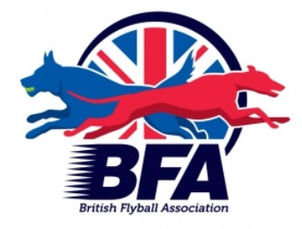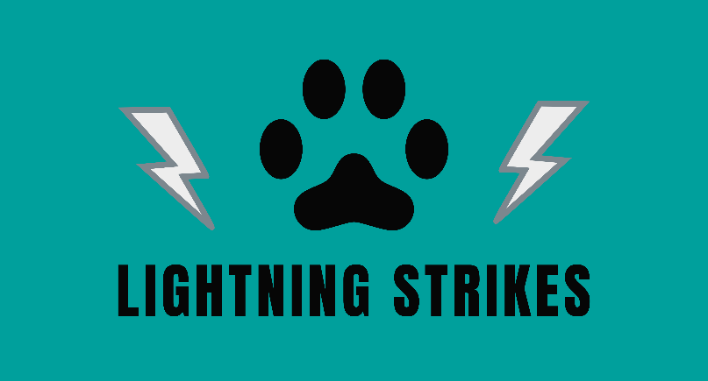

LIGHTNING STRIKES FLYBALL TEAM
BRITISH FLYBALL ASSOCIATION
LIMITED OPEN COMPETITION

Hedsor Golf Club
Broad Lane, Wooburn Common, Bucks, HP10 0JW

25-26 June 2022
CLOSING DATE: 24th May 2022

LIMITED OPEN TO 54 TEAMS

HEAD JUDGE: JASON BAKER

CONTACT: KIM SERMON – 07771 812862
*******EMAIL ENTRIES ONLY PLEASE*******
YOU WILL RECEIVE A CONFIRMATION OF ENTRY
lightning_strikes@live.co.uk

Golf – 9 hole pay & play available over the weekend

Camping available from 12:00 on Thursday 5th May until 7.00 p.m Sunday 8th May

CAMPING INFORMATION

Camping is STRICTLY LIMITED and must be booked in advance. Camping will be marked out, and you will be directed to your area upon arrival. We cannot guarantee we can accommodate late bookings.

There is a small club house with a bar and snacks. Under 18s must be accompanied by an adult at all times.

ENTRY FORM – Limited Open

Declared times must be submitted in writing (or email) at least 14 days before the
tournament and must be at least half a second faster or slower than seed time (Rule
4.4). Team break out time is quarter of a second faster than declared time (5.17(I)). All
times, seed or declared with the exception of Division One, are subject to the
Division breakout rule

TEAM NAME (£45.00 PER TEAM | TRN

Qualified Judges: Provisional Judges:
_________________________________________________________________________________

Camping (£10.00 per unit per night).

Please book and pay for in advance as camping pitches will be marked out. Late bookings may not be able to be accommodated.

FRIDAY | SATURDAY

Summary

OPEN TEAMS
CAMPING
TOTAL PAYMENT DUE

**** PLEASE ENSURE CAMPING IS PAID FOR IN ADVANCE****

Show Regulations:

- Current BFA Rules and Policies apply throughout the Sanctioned Tournament.
- The event organisers reserve the right to refuse entries and admission to the event of any person not in good standing within the BFA.
- No person shall carry out punitive or harsh handling of any dog.
- Bitches in season are not allowed near the tournament area.
- Mating of dogs is not allowed.
- Any bitch due to whelp within 7 days of the competitions is not permitted at the tournament.
- No bitch can compete whilst in pup and for at least eight weeks after giving birth.
- A dog must be withdrawn from the competition if it is suffering from an infectious or contagious disease, is a danger to the safety of any person or animal or if it is likely to cause suffering to the dog if it continues to compete.
- It is the Team Captain’s responsibility to ensure their team is available for their division.
- The organiser along with the Head Judge reserves the right to make necessary alterations in the event of unforeseen circumstances.
- If circumstances make it necessary to cancel the tournament, the organisers have the right to defray expenses incurred by deducting such expenses from the entry fees received.
- All dogs enter the event at their own risk. Every care will be taken to ensure the safety of the dogs and competitors but the tournament organiser cannot accept responsibility for damage, injury or loss caused to dogs or persons at the event.
- Competitors must pick up after their dogs. Anyone failing to do so will be asked to leave the venue.
- A two way tie will be decided by who beat who, a three way tie will be decided on fastest time.

Camping Regulations:

- Camping is limited, please be considerate when setting up.
- All vehicles should keep to 5mph on the venue. Please keep driving during the tournament to a minimum.
- Please ensure generators are switched off between 11pm and 7am.
- Barbeques are allowed but please take extra care and ensure there is a water bucket to hand.
- Please pick up dog waste and litter.

STRICTLY NO DOGS ALLOWED ON THE GOLF COURSE AT ANY TIME

