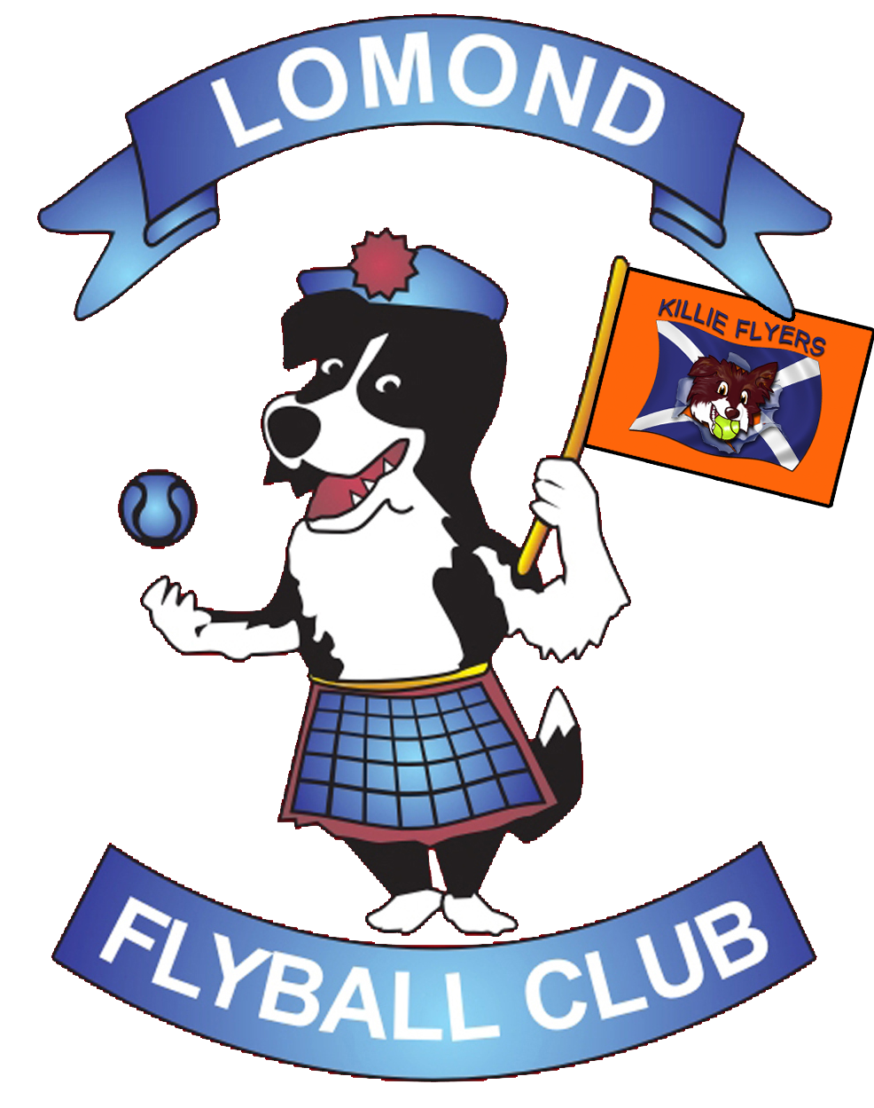
CO-HOSTED WITH KILLIE FLYERS

British Flyball Association
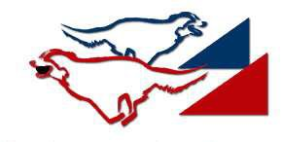

Sanctioned
Limited Open Tournament
(54 Teams)
at
Greenfield Farm, Strathaven,
South Lanarkshire, Scotland, ML10 6QF

8th & 9th JULY 2017
(Closing Date 8th June 2017)

Electronic entries accepted

https://www.iball4flyball.co.uk/tournaments/index.php?tournament=LR_Jul17

Entries to: Jenni Wallace
1A Manse Drive
Balloch, Alexandria,
West Dunbartonshire
G83 8HG
For Further information please contact
Sarah Wallace
Mobile: 07808 912599
Email: sarah@lomond-flyball.co.uk

Lomond Flyball Club
CO-HOSTED WITH KILLIE FLYERS

Directions to Greenfield Farm, Strathaven, ML10 6QF

From the North:
Drive to Glasgow (M8)
On M8, At Junction 8, exit onto Swinhill Rd/A71 towards Kilmarnock/Edinburgh
Continue onto A71 Kilmarnock/Edinburgh
At the roundabout, Take the 2nd exit and stay on Swinhill Rd/A71
Continue to follow A71
At roundabout, take the 1st exit and stay on A71
Turn Left
Destination will be on the right and will be well sign posted for Greenfield Farm Entrance

From the South:
Continue onto the M74
At Junction 8, take the A71/B7078 exit to Kilmarnock/Edinburgh/Larkhall
At the roundabout, take the 2nd exit onto Swinhill Rd/A71
Continue to follow A71 Kilmarnock
At the roundabout, take the 1st exit and stay on A71
Turn Left
Destination will be on the right and will be well sign posted for Greenfield Farm Entrance

Show rules and regulations

- The tournament organisers reserve the right to refuse entries and admission to any person not in good standing with the BFA.
- No person shall impugn the decisions of the Head Judge or Judges.
- Bitches in season are not allowed near the show area, mating of dogs is not allowed.
- It is the Team Captains responsibility to ensure the team is available for their class and running order.
- The organisers reserve the right to make any alterations they deem necessary in event of unforeseen circumstances.
- All dogs are entered in this event at their owners risk and, whilst every care will be taken, the event organisers cannot accept responsibility for damage, injury or loss however caused to dogs, persons or property whilst at the event.
- A dog must be withdrawn from competition if it is:
- Suffering from infectious or contagious diseases;
- A danger to the safety of any person or animal; or
- Likely to cause suffering to the dog if it continues to compete.
- All owners/handlers must clean up after their dogs. Anyone failing to do so will be asked to leave the venue.
- If circumstances make it necessary that the tournament is cancelled, the organisers reserve the right to defray expenses incurred by deducting such expenses from entry fees received.
- Current BFA Rules and Policies will apply throughout the Sanctioned Tournament.

THANK YOU!

Lomond Flyball Club
CO-HOSTED WITH KILLIE FLYERS

Entry Form for BFA Sanctioned Limited Open Tournament
(Limited to 54 Teams)

Greenfield Farm, Strathaven,
South Lanarkshire, Scotland, ML10 6QF

8th & 9th JULY 2017
(Closing Date 8th June 2017)
Entry fee £40 per Team

Declared times must be submitted in writing (or email) at Least 14 days before the tournament and must be at least half a second faster or slower than seed time. (BFA rule 4.4) Team break out time is half a second faster than declared time (BFA rule 5.17(I))
All times, seed or declared, except Div 1, are subject to the division break out rule.

 | Team Name | BFA No
1
2
3
4
5
6

Team Captain
Address:
Tel No:
Email:

If you can provide a Judge for our show, please indicate this below:

Provisional Judge: Qualified Judge:

See over for Starters Entry and information about camping requirements.

Lomond Flyball Club
CO-HOSTED WITH KILLIE FLYERS

Starters Competition Entry Form

8th & 9th JULY 2017
(Closing Date: 8th June 2017)

Entry fee: £25 per Starters Team

Starters Team Name
1
2
3
4
5
6

Show Details & information
- The show will be run outdoors on grass
- RR Block
- “Chewin’ the Fat” catering van available on-site
- Co-hosted with Killie Flyers

Lomond Flyball Club
CO-HOSTED WITH KILLIE FLYERS

FINANCIAL INFORMATION AND CAMPING BOOKING

Camping @ £8 per unit per night | Number of  caravans | Number of  tents | Total
Friday |  |  | £
Saturday |  |  | £

Camping MUST be paid for in advance.
Access available from 2pm on Friday.

 | Total to Pay
Number of camping units @ £8 per night | £
Number of Open Teams entered @ £40 per team | £
Number of Starters Teams entered @ £25 per team | £
Overall Total | £

Cheque enclosed for £ (Cheques payable to LOMOND FLYBALL CLUB)

(Please supply email for tournament info & running orders)

Electronic payments must be made by 8th June 2017

If you fail to gain entry due to oversubscription, a refund of electronic fees will be honored.

Thank you for your entry and we look forward to welcoming you to our show!

