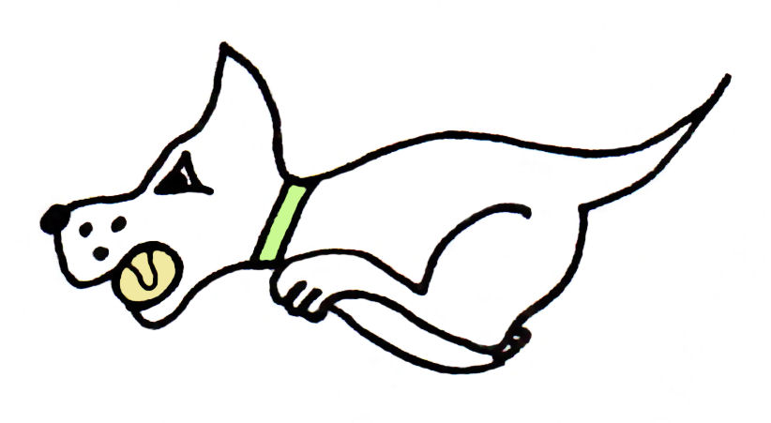
Kennet Flyball Club

present a

LIMITED OPEN TOURNAMENT (42 TEAMS)

Plus
Foundation on Saturday

****Please note our new venue****

At

Diggers Field, Ansty Park
Alton
GU24 2NB

3rd + 4th September 2022

(Closing date for entries: 2nd August 2022)

Information

Electronic entries accepted

Camping £10 per unit per night
Camping available from 2pm Friday

Kennet Flyball Club
Tournament Rules and Regulations

Requests for specific days
As always, we will try to accommodate teams who request specific days however this cannot be guaranteed. The running order cannot be considered until two weeks prior to the event at the earliest due to the seed list update and therefore it is impossible to guarantee any request until that time whether successful or not. Refunds will not be issued if we are unable to accommodate your request and you withdraw beyond the competition closing date.

(1) The Tournament Organiser(s) reserve the right to refuse entries and admission to
the event of any persons not in good standing within the BFA.

(2) No person shall carry out punitive or harsh handling of a dog at the event.

(3) Bitches in season are not allowed near the tournament area. Mating of dogs is not
allowed. Any bitch due to whelp within seven days of the competitions is not
permitted at the Tournament. No bitch can compete whilst in pup and for at least
eight weeks after giving birth.

(4) A dog must be withdrawn from competition if it is:
(A) Suffering from infectious or contagious diseases.
(B) A danger to the safety of any person or animal.
(C) Likely to cause suffering to the dog if it continues to compete.

(5) It is the Team Captain’s responsibility to ensure the Team is available for their
Division and running order.

(6) The Organiser(s) reserve the right to make any alterations they deem necessary in
the event of unforeseen circumstances.

(7) If circumstances make it necessary to cancel the Tournament, the Organiser(s)
reserve the right to defray expenses incurred by deducting such expenses from the
entry fees received.

(8) All dogs enter the event at their own risk and whilst every care will be taken, the
Tournament Organiser(s) cannot accept responsibility for damage, injury, or loss
however caused to dogs, persons or property whilst at the event.

(9) All owners/handlers must clear up after their dogs. Anyone failing to do so will be
asked to leave the venue.

(10) Current BFA Rules and Policies will apply throughout the Sanctioned Tournament.

(11) No person shall impugn the decision of the head judge or judges.

(12) No ground level BBQs are allowed

(13) Entry into the show grants you temporary membership of Kennet Flyball Club and all the benefits and conditions thereof.

Kennet Flyball Club
LIMITED OPEN TOURNAMENT
(42 TEAMS) Sep 2022
Declared times must be submitted in writing (or email) at Least 14 days before the tournament and must be at least half a second slower or faster than the current seed time. (BFA rule A.1 4.3)
Team break out time is a quarter of a second faster than declared time (BFA rule A.3. 11)
All times, seed or declared, except Div 1, are subject to the division break out rule.

Team Name: | BFA Number
1)
2)
3)
4)
5)

Team Captain:

BFA Number:

Telephone number:

Email:

If you are able to provide a judge for our show, please indicate this below.

Provisional Judge

Qualified Judge

Measurer (P or Q)

Kennet Flyball Club

FOUNDATION TOURNAMENT

Sat 3 Sept 2022

Team Name:

1)
2)
3)
4)
5)

Team Captain:

Telephone:

Email:

Kennet Flyball Club
FINANCIAL SUMMARY
Sep 2022

 | Numbers | Cost | Sub-totals
Your Club/Team name:

Number of open teams entered |  | @ £45.00 each
Number of foundation teams entered |  | @ £40.00 each
Camping £10 per unit per night
Camping can be paid in advance or on the day, or a mix of both

Fri | Sat | Sun
 |  | GRAND TOTAL

Electronic entries accepted.
Please email to : shows@kennetflyballclub.co.uk

Please use the email shows@kennetflyballclub.co.uk only.
Requests via messenger/facebook, will not be accepted.

Bank details for payment:
Pay to: Kennet Flyball Club
Barclays bank Sort code 20-05-00 A/C number 63520234
Ref : please enter your club name

Should we be oversubscribed entries will be refunded.

Enquiries Tel: Ivan 07747051435

