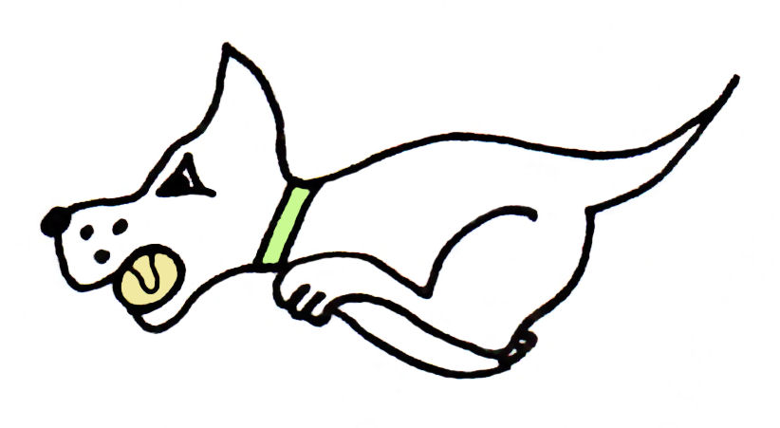
Kennet Flyball Club

present an

Open Tournament

Plus
Foundation on Saturday

At

Diggers Field, Ansty Lane,
Ansty Park, Alton, Hampshire
GU34 2NB
What3words: shade.wobbling.sandals

2nd + 3rd September 2023

(Closing date for entries: 18th August 2023)

Information

Contact email shows@kennetflyballclub.co.uk

Enquiries Tel: Andrea 07766 545277 or Ivan 07747 051435

Declared times must be received by Thurs 17 Aug

Camping £10 per unit per night
Camping available from 12pm Friday 1st Sep

Kennet Flyball Club
Tournament Rules and Regulations

Requests for specific days
As always, we will try to accommodate teams who request specific days however this cannot be guaranteed. The running order cannot be considered until two weeks prior to the event at the earliest due to the seed list update and therefore it is impossible to guarantee any request until that time whether successful or not. Refunds will not be issued if we are unable to accommodate your request and you withdraw beyond the competition closing date.

(1) The Tournament Organiser(s) reserve the right to refuse entries and admission to
the event of any persons not in good standing within the BFA.

(2) No person shall carry out punitive or harsh handling of a dog at the event.

(3) Bitches in season are not allowed near the tournament area. Mating of dogs is not
allowed. Any bitch due to whelp within seven days of the competitions is not
permitted at the Tournament. No bitch can compete whilst in pup and for at least
eight weeks after giving birth.

(4) A dog must be withdrawn from competition if it is:
(A) Suffering from infectious or contagious diseases.
(B) A danger to the safety of any person or animal.
(C) Likely to cause suffering to the dog if it continues to compete.

(5) It is the Team Captain’s responsibility to ensure the Team is available for their
Division and running order.

(6) The Organiser(s) reserve the right to make any alterations they deem necessary in
the event of unforeseen circumstances.

(7) If circumstances make it necessary to cancel the Tournament, the Organiser(s)
reserve the right to defray expenses incurred by deducting such expenses from the
entry fees received.

(8) All dogs enter the event at their own risk and whilst every care will be taken, the
Tournament Organiser(s) cannot accept responsibility for damage, injury, or loss
however caused to dogs, persons or property whilst at the event.

(9) All owners/handlers must clear up after their dogs. Anyone failing to do so will be
asked to leave the venue.

(10) Current BFA Rules and Policies will apply throughout the Sanctioned Tournament.

(11) No person shall impugn the decision of the head judge or judges.

(12) No ground level BBQs are allowed

Kennet Flyball Club
OPEN TOURNAMENT
Sep 2023
Declared times must be submitted in writing no later than 14 days before the tournament and must be at least half a second slower or faster than the current seed time. (BFA rule A.1 4.3)
Team break out time is quarter of a second faster than declared time (BFA rule A.3.11)
All times, seed or declared, except Div 1, are subject to the division break out rule.

Team Name: | BFA Number
1)
2)
3)
4)
5)

Team Captain:

BFA Number:

Telephone number:

Email:

If you are able to provide a judge for our show, please indicate this below.

Provisional Judge

Qualified Judge

Measurer (P or Q)

Kennet Flyball Club

FOUNDATION TOURNAMENT

Sat 2 Sept 2023

Team Name:

1)
2)
3)
4)
5)

Team Captain: BFA No.

Telephone:

Email:

If not already advised under open entries

If you are able to provide a judge for our show, please indicate this below.

Provisional Judge

Qualified Judge

Measurer (P or Q)

Kennet Flyball Club
FINANCIAL SUMMARY
Sep 2023

 | Numbers | Cost | Sub-totals
Your Club/Team name:

Number of open teams entered |  | @ £45.00 each | £
Number of foundation teams entered |  | @ £40.00 each | £
Camping £10 per unit per night
Camping can be paid in advance or on the day, or a mix of both

Fri | Sat | Total | £
 |  | GRAND TOTAL

Electronic entries accepted.
Please email to : shows@kennetflyballclub.co.uk

Please use the email shows@kennetflyballclub.co.uk only.
Requests via messenger/facebook, will not be accepted.

Bank details for payment:
Pay to: Kennet Flyball Club
Barclays bank Sort code 20-05-00 A/C number 63520234
Ref : please enter your club name

Should we be oversubscribed entries will be refunded.

Enquiries Tel: Andrea 07766 545277 or Ivan 07747 051435

