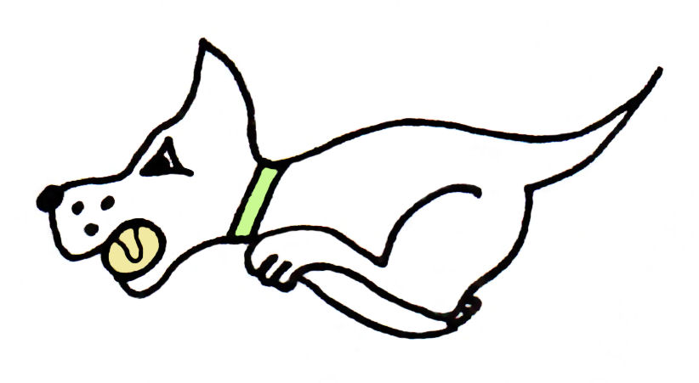
Kennet Flyball Club

present a

LIMITED OPEN TOURNAMENT (42 TEAMS)

Plus
One Division of Starters on Saturday

At

Padworth Village Hall, Padworth Lane,
Pawdorth, Berks, RG7 4HY
(just off A4)

25 & 26 April 2020

(Closing date for entries: 25TH March 2020)

Information

Electronic entries accepted

Hot Food and drinks will be available on site, toilets and showers.

Camping Facilities £9 per unit per night, possibility of staying Sunday Night if pre arranged.

Kennet Flyball Club
Tournament Rules and Regulations

Requests for specific days
As always we will try to accommodate teams who request specific days however this cannot be guaranteed. The running order cannot be considered until two weeks prior to the event at the earliest due to the seed list update and therefore it is impossible to guarantee any request until that time whether successful or not. Refunds will not be issued if we are unable to accommodate your request and you withdraw beyond the competition closing date.

(1) The Tournament Organiser(s) reserve the right to refuse entries and admission to
the event of any persons not in good standing within the BFA.

(2) No person shall carry out punitive or harsh handling of a dog at the event.

(3) Bitches in season are not allowed near the tournament area. Mating of dogs is not
allowed. Any bitch due to whelp within seven days of the competitions is not
permitted at the Tournament. No bitch can compete whilst in pup and for at least
eight weeks after giving birth.

(4) A dog must be withdrawn from competition if it is:
(A) Suffering from infectious or contagious diseases.
(B) A danger to the safety of any person or animal.
(C) Likely to cause suffering to the dog if it continues to compete.

(5) It is the Team Captain’s responsibility to ensure the Team is available for their
Division and running order.

(6) The Organiser(s) reserve the right to make any alterations they deem necessary in
the event of unforeseen circumstances.

(7) If circumstances make it necessary to cancel the Tournament, the Organiser(s)
reserve the right to defray expenses incurred by deducting such expenses from the
entry fees received.

(8) All dogs enter the event at their own risk and whilst every care will be taken, the
Tournament Organiser(s) cannot accept responsibility for damage, injury, or loss
however caused to dogs, persons or property whilst at the event.

(9) All owners/handlers must clear up after their dogs. Anyone failing to do so will be
asked to leave the venue.

(10) Current BFA Rules and Policies will apply throughout the Sanctioned Tournament.

(11) No person shall impugn the decision of the head judge or judges.

(12) No ground level BBQs are allowed

Kennet Flyball Club
LIMITED OPEN TOURNAMENT
(42 TEAMS) April 2020
Declared times must be submitted in writing (or email) at Least 14 days before the tournament and must be at least half a second slower or half a second faster than the current seed time. (BFA rule A.1 4.3)
Team break out time is half a second faster than declared time (BFA rule A.3. 11)
All times, seed or declared, except Div 1, are subject to the division break out rule.

Team Name: | BFA Number
1)
2)
3)
4)
5)

Team Captain:

BFA Number

Address:

Post Code:

Telephone:

Email:

If you are able to provide a judge for our show, please indicate this below.
Provisional Judge

Qualified Judge

Measurer (P or Q)

Kennet Flyball Club
STARTERS TOURNAMENT
Sat 25 April 2020

Team Name:

1)
2)
3)
4)
5)

Team Captain:

Address:

Post Code:

Telephone:

Email:

If you are able to provide a judge or measurer for our show, please indicate this below.

Provisional Judge

Qualified Judge

Measurer (P or Q)

Kennet Flyball Club
FINANCIAL SUMMARY April 2020

 | Numbers | Cost | Sub-totals
Your Club/Team name:

Number of open teams entered |  | @ £45.00 each
Number of starters teams entered |  | @ £40.00 each
Camping £9 per unit per night

Fri | Sat | Sun
 |  | GRAND TOTAL

Electronic entries accepted.
Please email to : shows@kennetflyballclub.co.uk

Please use the email shows@kennetflyballclub.co.uk only.
Requests via messenger/facebook, will not be accepted.

Bank details for payment:
Pay to: Kennet Flyball Club
Barclays bank Sort code 20-05-00 A/C number 63520234
Ref : please enter your club name

Should we be oversubscribed entries will be refunded.

Postal entries also accepted:

Please make all cheques payable to Kennet Flyball Club

Please advise your email address for tournament information and running orders.

Address for postal entries:

Kennet Flyball
5 Rectory Close,
Tadley,
Hampshire
RG26 3PH

Enquiries Tel: Mhairi 07584 198 399

