th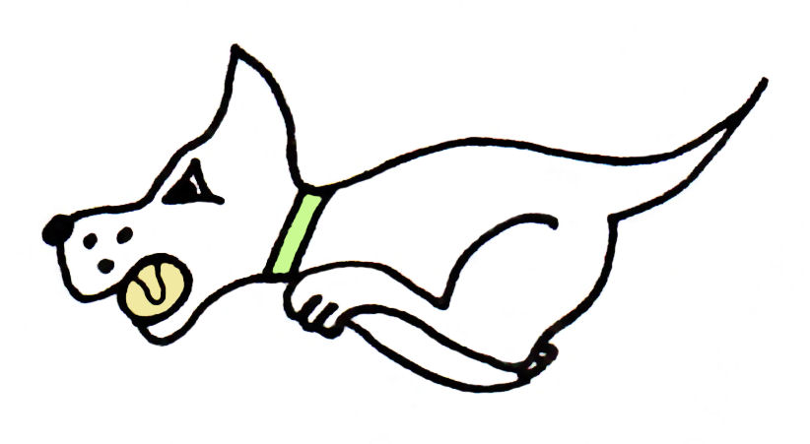
Kennet Flyball Club

present a

LIMITED OPEN TOURNAMENT (36 TEAMS)

At

Newbury Showground, Priors Court, Hermitage,
Thatcham, Berks, RG18 9QZ

15 & 16 April 2023
(Closing date for entries: 10TH March 2023)

Information

Hot Food and drinks will be available on site, toilets and showers.

In conjunction with the ‘All About Dogs Show’

Camping Facilities £30 per unit for Fri - Sun (vacate by 9pm)
needs to be pre-booked & paid for once your entry is confirmed
camping is very limited & its first come first served

Entry to the competition will allow entry into
the All About Dogs Show and the Garden show.

There will be a sectioned off area for Flyball camping & day parking next to where the tournament is being held. You need to arrive before 8am & not leave until after 5pm as there is no traffic movement on the showground outside of these hours.

We will be running a ‘Have A Go Flyball Run’ in aid of the ‘Pensions for Paws’ charity raising money to cover Vets Fees for retired Police & Fire Dogs.
Any help with this is appreciated

Contact email shows@kennetflyballclub.co.uk

Kennet Flyball Club
Tournament Rules and Regulations

Requests for specific days
As always we will try to accommodate teams who request specific days however this cannot be guaranteed. The running order cannot be considered until two weeks prior to the event at the earliest due to the seed list update and therefore it is impossible to guarantee any request until that time whether successful or not. Refunds will not be issued if we are unable to accommodate your request and you withdraw beyond the competition closing date.

(1) The Tournament Organiser(s) reserve the right to refuse entries and admission to
the event of any persons not in good standing within the BFA.

(2) No person shall carry out punitive or harsh handling of a dog at the event.

(3) Bitches in season are not allowed near the tournament area. Mating of dogs is not
allowed. Any bitch due to whelp within seven days of the competitions is not
permitted at the Tournament. No bitch can compete whilst in pup and for at least
eight weeks after giving birth.

(4) A dog must be withdrawn from competition if it is:
(A) Suffering from infectious or contagious diseases.
(B) A danger to the safety of any person or animal.
(C) Likely to cause suffering to the dog if it continues to compete.

(5) It is the Team Captain’s responsibility to ensure the Team is available for their
Division and running order.

(6) The Organiser(s) reserve the right to make any alterations they deem necessary in
the event of unforeseen circumstances.

(7) If circumstances make it necessary to cancel the Tournament, the Organiser(s)
reserve the right to defray expenses incurred by deducting such expenses from the
entry fees received.

(8) All dogs enter the event at their own risk and whilst every care will be taken, the
Tournament Organiser(s) cannot accept responsibility for damage, injury, or loss
however caused to dogs, persons or property whilst at the event.

(9) All owners/handlers must clear up after their dogs. Anyone failing to do so will be
asked to leave the venue.

(10) Current BFA Rules and Policies will apply throughout the Sanctioned Tournament.

(11) No person shall impugn the decision of the head judge or judges.

(12) No ground level BBQs are allowed

Kennet Flyball Club
LIMITED OPEN TOURNAMENT
(36 TEAMS) April 2023
Declared times must be submitted in writing (or email) no later than 14 days before the tournament and must be at least half a second slower or faster than the current seed time. (BFA rule A.1 4.3)
Team break out time is quarter of a second faster than declared time (BFA rule A.3.11)
All times, seed or declared, except Div 1, are subject to the division break out rule.

Team Name: | BFA Number
1)
2)
3)
4)
5)

Team Captain:

Telephone:

Email:

If you are able to provide a judge for our show, please indicate this below.

Provisional Judge

Qualified Judge

Measurer (P or Q)

Kennet Flyball Club

FINANCIAL SUMMARY April 2023

 | Numbers | Cost | Sub-totals
Your Club/Team name:

Number of open teams entered |  | @ £45.00 each
Number of camping pitches@ £30

 |  | GRAND TOTAL

Please note Tournament email address:

Please email to : shows@kennetflyballclub.co.uk

Any queries contact

Andrea 07766 545 277
Ivan 07747 051 435

Payment details will be advised when the entries are accepted.

