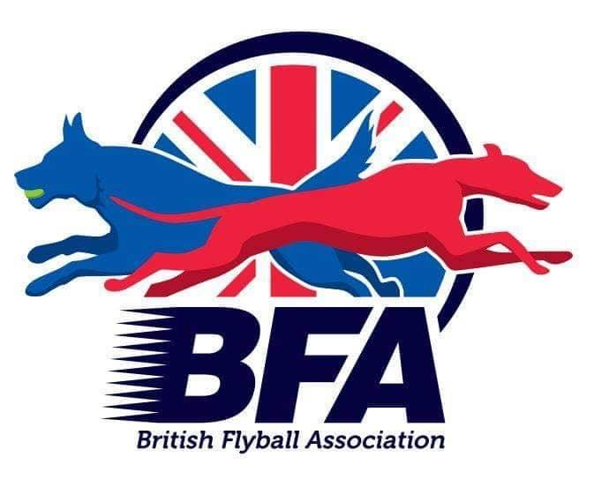

The British Flyball Association

Presents the

British Flyball Association

2023 INDOOR CHAMPIONSHIPS

LIMITED OPEN SANCTIONED TOURNAMENT (96 Teams)

13th to 15th October 2023

(Closing date for entries 12th September 2023)

To be held at

Newark Showground, NG24 2NY.

Electronic Entries (please note emailed entries will not be accepted):

<https://forms.gle/T4QKoRxNs5eQ2krS9>

Please send any queries to: secretary@bfa.email

Payment should be made via BACs to:

The British Flyball Association

Lloyds Bank

30-93-45

00417549