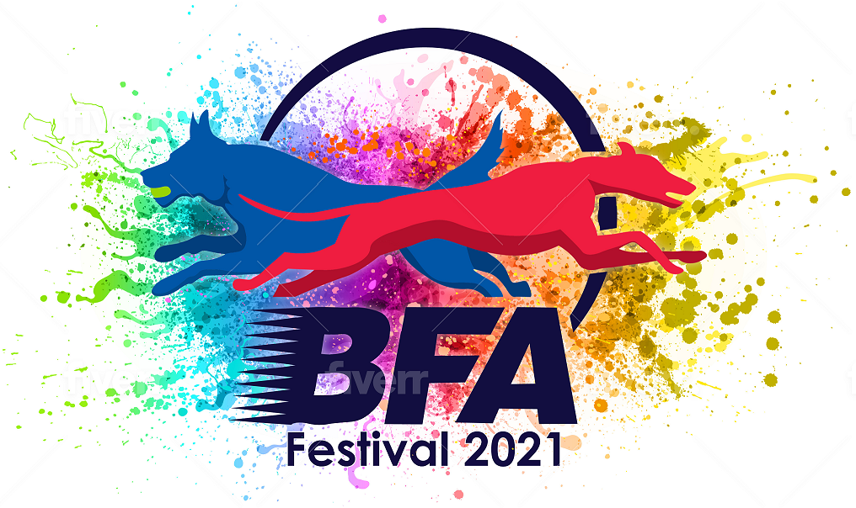

The British Flyball Association

Sponsored by

Presents the
2021 Flyball Festivals
LIMITED OPEN SANCTIONED TOURNAMENTS
(100 Teams Indoor and 240 Teams Outdoor)

Indoor Flyball Festival

6th, 7th and 8th August 2021
To be held at

Three Counties Showground, Malvern, Worcestershire, WR13 6NW

Outdoor Flyball Festival

12th, 13^{th,} 14th and 15th August 2021
To be held at

Driffield Showground, Kelleythorpe, Driffield, YO25 9DN

Postal entries to:
Katie Burns, 35 Stamford Close, Macclesfield, Cheshire, SK11 7TZ

Electronic Entries (please note emailed entries will not be accepted):
https://docs.google.com/forms/d/e/1FAIpQLSdtTU-WCKWyvJWy81AA9hj8BkET_-41fr4vhcc70sI2rH1OGA/viewform

For any queries: bfachamps@gmail.com
PLEASE NOTE:
1. Postal entries will NOT be accepted without accompanying payment by cheque or postal order.
2. Electronic entries MUST be paid within 7 days of notification of successful entry - payment instructions will be sent by email.

British Flyball Association Flyball Festivals
LIMITED OPEN SANCTIONED TOURNAMENT
Three Counties Showground, Malvern, Worcestershire, WR13 6NW
Closing date for entries 12th July 2021
Declared times must be submitted in writing (or email) at least 14 days before the tournament and must be at least a half a second slower or faster than seed time. Teams not on the seed list must submit a time and will be subject to the team break-out rule.

Team Name(s) | BFA Team Number
1
2
3
4
5
6
7
8
Team Captain

Name: | Address:
Phone Number:
E-Mail Address:

Electronic entries MUST include an email address.

Financial (No postal entries accepted without payment)

 | Price (Incl Vat) | Number | Cost
Open teams entered... | £50/team
Camping Units... Please complete the camping form on the next page. All camping is subject to availability and must be pre-booked by 25th July 2021 | £40/unit
Total £ (cheques payable to British Flyball Association)
Payment instructions for electronic entries will be sent by email. Payment required within 7 days

British Flyball Association Flyball Festivals
LIMITED OPEN SANCTIONED TOURNAMENT
Driffield Showground, Kelleythorpe, Driffield, YO25 9DN
Closing date for entries 12th July 2021
Declared times must be submitted in writing (or email) at least 14 days before the tournament and must be at least a half a second slower or faster than seed time. Teams not on the seed list must submit a time and will be subject to the team break-out rule.

Team Name(s) | BFA Team Number
1
2
3
4
5
6
7
8
Team Captain

Name: | Address:
Phone Number:
E-Mail Address:

Electronic entries MUST include an email address.

Financial (No postal entries accepted without payment)

 | Price (Incl Vat) | Number | Cost
Open teams entered... | £50/team
Camping Units... Please complete the camping form on the next page. All camping is subject to availability and must be pre-booked by the 1st August 2021 | £50/unit
Total £ (cheques payable to British Flyball Association)
Payment instructions for electronic entries will be sent by email. Payment required within 7 days

British Flyball Association Flyball Festivals

LIMITED OPEN SANCTIONED TOURNAMENT

Three Counties Showground, Malvern, Worcestershire, WR13 6NW
Closing date for camping entries 25th July 2021

CAMPING FORM
Camping @ £40 per unit for the tournament (1pm Thursday – 10:00am Mon).

Team Name :
Primary TRN:

Number of camping units required

Camping is strictly limited to current BFA members. Please tick the box to confirm that all campers are current BFA members

Details of assisted / disabled requirements
(Only if this is required)
_________________________________________________________________________________________________________________________________________________________________________________________________________________________________________________________________________________________________________________

British Flyball Association Flyball Festivals

LIMITED OPEN SANCTIONED TOURNAMENT

Driffield Showground, Kelleythorpe, Driffield, YO25 9DN
Closing date for camping entries 1st August 2021

CAMPING FORM
Camping @ £50 per unit for the tournament (1pm Wednesday – 10:00am Mon).

Team Name :
Primary TRN:

Number of camping units required

Camping is strictly limited to current BFA members. Please tick the box to confirm that all campers are current BFA members

Details of assisted / disabled requirements
(Only if this is required)
_________________________________________________________________________________________________________________________________________________________________________________________________________________________________________________________________________________________________________________

Foundation Flyball, Singles and Pairs

Foundation Flyball, Singles and Pairs will be offered where there is available capacity. These will only be offered for dogs not already competing in open racing. Please indicate numbers

Number of entries
Indoor festival – Foundation £25 per team
Indoor festival – Singles £5 per dog
Indoor festival – Pairs £10 per pair
Outdoor festival - Foundation £25 per team
Outdoor festival - Singles £5 per dog
Outdoor festival - Pairs £10 per pair

INFORMATION ABOUT THE FORMAT

The Flyball Festivals will be run to a different format from the usual Championships format.

Speed Trials will be for all entered teams and these will be run on the Friday of the Indoor Festival and on the Thursday and Friday morning of the Outdoor Festival. This will give each team 9 runs in order to record the fastest time it can. This will be arranged as 3 races per team and each race will be 3 heats. Each team must attempt to run 4 dogs in each heat.

Speed Trial racing is all about the time - it is not about winning or losing races. Expect exciting racing as teams battle to get into the highest division they can, with the best seeding they can manage. There may be lights as teams try to squeeze the last few 100ths of a second off their time. Please note that all dogs on the team sheet need to complete at least three legs during speed trials to be eligible to race in the round robin.

These dogs are then rested in preparation for the Round Robin competition (5 team divisions) which will be held over the weekend at both Festivals. These will be run in speed order with the slower teams racing Saturday and the faster teams racing Sunday.

SHOW RULES AND REGULATIONS

  - The tournament organiser(s) reserve the right to refuse entries and admission to any person not in good standing with the B.F.A.
  - No person shall carry out punitive or harsh handling of a dog at the tournament.
  - It is the Team Captains responsibility to ensure the Team is available for its class and running order.
  - The organiser(s) reserve the right to make any alterations they deem necessary in the event of unforeseen circumstances.
  - Bitches in season are not allowed near the show area. Mating of dogs is not allowed.
  - A dog must be withdrawn from competition if it is:
    - Suffering from any infectious or contagious disease
    - A danger to safety of any person or animal
    - Likely to cause suffering to the dog if it continues to compete
  - All dogs enter into the tournament at their own risk and whilst every care will be taken, the organiser(s) cannot accept responsibility for damage, injury or loss however caused to dogs, persons or property whilst at the event.
  - All owners/handlers must clean up after their dogs. Anyone failing to do so will be asked to leave the venue.
  - BFA rules and policies will apply throughout the sanctioned tournament.
  - No alcohol is to be consumed within or around the ring.
  - If circumstances make it necessary that the tournament is cancelled, the organisers reserve the right to defray expenses incurred by deducting such expenses from entry fees received.
  - On and around the flyball and camping fields a strict speed limit (5 mph) will apply and vehicle movement restrictions will apply throughout the event.
  - Any COVID restrictions that are put in place must be adhered to.

Entries will be taken on date of receipt as for all sanctioned tournaments: Rule A.1.3.6.
For any queries please email: bfachamps@gmail.com

A maximum of two minutes warm up will be allowed between races.

Please note that the Indoor Festival is a three day tournament and the Outdoor Festival is a four day tournament. You may therefore be racing, ring party or judging on any/all of the days. Please do not enter if you are unable to fulfil your tournament responsibilities on all days as refusal of these responsibilities will jeopardise your entry and any future entries to BFA events.

Please tick to confirm that your team is available all entered days

If you have entered both tournaments please highlight your preferred tournament in case of over subscription.

Indoor Festival

Outdoor Flyball Festival

