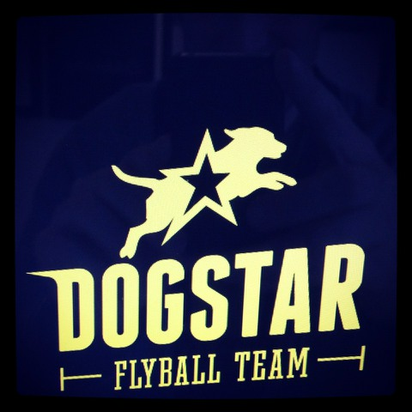

Presented at

Driffield Agricultural Showground
YO25 9DN

Limited Starters Tournament
Friday 10th April 2020

BFA Sanctioned Limited Open

60 teams over 2 days

Sat 11th April – Sun 12th April 2020

BFA Sanctioned Limited Multibreed

24 teams

Monday 13th April 2020

Closing Date For entries 11th March 2020

Entries: Julie Huggins
Railway Cottage
Main Street
Asselby
East Yorkshire DN14 7HE
Tel: 01757 638191
Email: melorawhippet@gmail.com

Starters Competition
Friday 10th April 2020

Team Name |  | Estimated Time
1
2
3
4
Team Captain
Address
Telephone |  | Email

Entry fee £25 per team (please see Entry Summary Form)

Sanctioned Limited Open
Saturday 11th- Sunday 12th April 2020

Declared times must be submitted in writing (or email) at least 14 days before the tournament and must be at least half a second faster or slower than seed time (Rule 4.4).
Team break out time is half a second faster than declared time (5.17(l)).
All times, seed or declared, except Division 1, are subject to the Division break out rule.

Team Name |  |  |  | Team Number
1
2
3
4
5
6
Team Captain: |  |  | BFA No:
Address
Telephone |  | Email

Entry fee £45 per team (please see Entry Summary Form)

Sanctioned Limited Multibreed Tournament
Monday 13th April 2020

N.B. Declared times for all teams will be required by Monday 13th April 2020
With the exception of Division 1 the team break out time is half a second faster than declared time (5.17(l)).

Team Name |  |  |  | Team Number
1
2
3
4
Team Captain: |  |  | BFA No:
Address
Telephone |  | Email

Entry fee £45 per team (please see Entry Summary Form)

Entry Summary Form  Team Name ___________ | Total
No of Starters teams entered _______ at £ 25 per team | £
No. of Open Teams entered _______ at £45 per team | £
No. of Multibreed Teams entered ______at £45 per team | £
Total no of sleeping units (caravans/tents) @£9 per night ______  Thurs _____ Friday _____ Saturday _____ Sunday _____  Monday ______ | £
Cheque made payable to DogStar Flyball please Total | £

Judging – Please indicate if anyone from your team would be happy to judge a division and indicate whether Head Judge / Qualified Judge / Provisional Judge/ Dog Measurer.

Show rules and regulations

N.B Team Captains/ Managers are responsible for ensuring that all members of their teams and accompanying party are informed of the rules and regulations pertaining to this tournament.

1. The event organiser reserves the right to refuse entries and admission to the event of a) any person not in good standing with the BFA or b) any person not complying with the request of the parking stewards or security personnel.

2. No person shall carry out punitive or harsh handling of a dog at the event.

3. Bitches in season are not allowed near the show area. Mating of dogs at the event is not allowed.

4. A dog must be withdrawn from the competition if it is:-
a) Suffering from any infectious or contagious disease.
b) A danger to the safety of any person or animal.
c) Likely to cause suffering to the dog if it continues to compete.

5. It is the team captain’s responsibility to ensure that the team is available for its races.

6. No person shall impugn the decision of the head judge or judges.

7. The organiser reserves the right to make any alterations deemed necessary in the event of unforeseen circumstances.

8. All dogs are entered in this event at their owners risk and, whilst every care will be taken, the event organiser cannot accept responsibility for damage, injury or loss however caused to dogs, persons or property whilst at the event.

9. All owners/handlers must clear up after their dogs anywhere in the grounds. Anyone failing to do so will be asked to leave the venue.

10. Each team captain must ensure that all rubbish is removed or put in the skip before leaving the site.

11. All dogs are to be kept on a lead when not actually racing.

12. If circumstances make it necessary to cancel the tournament, the organisers reserve the right to defray expenses incurred by deducting such expenses from the entry fees received.

13. Current BFA Rules and Policies will apply throughout the Tournament.

14. All teams entering are expected to assist with ring party duties as requested by the tournament organiser.

15. A speed limit of 15 m.p.h. for all vehicles must be observed at the venue at all times. Please keep to the roadways whenever possible.

