Barkshire Bandits
Flyball Team

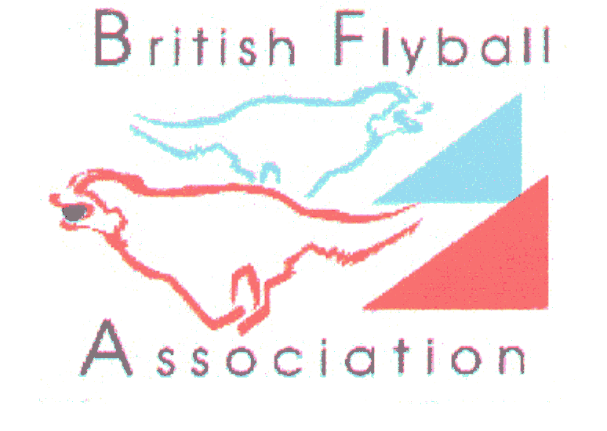
Present

LIMITED OPEN

SANCTIONED COMPETITION

at

DIANA BRIMBLECOMBE ANIMAL RESCUE CENTRE

Nelsons Lane, Hurst, Nr Wokingham, Berkshire.

RG10 0RR

on
SATURDAY/ SUNDAY
23rd & 24TH September 2017
Closing date 22nd August 2017

FEATURING: LIMITED 48 TEAM COMPETITION

FOR FURTHER INFORMATION CONTACT:
PENNY CHARLTON TEL:01628 829623

EMAIL: penny.barkshirebandits@yahoo.co.uk

Barkshire BanditsFlyball Team

Limited Open Sanctioned Competition

Diana Brimblecombe Rescue Centre
23/24th September 2017 (48 teams)
Closing date for entries: 22nd September 2017
Declared times must be submitted in writing (or email) at least 14 days before the tournament and
must be at least half a second faster or slower than seed time (Rule 4.4).
Team break out time is half a second faster than declared time (5.17(l))
All times, seed or declared, except Div 1, are subject to the Division break-out rule.

Team Name | BFA No

Team Captain:
Address

Telephone:
Email:

No Of Teams Entered ______@ £40 per Team = £_____________

Camping @ £8 per unit per night = £ _____________

TOTAL ENCLOSED = £_____________

If time, a starters competition may be run, if interested please tick here...........................

JUDGING: Please name anyone from your team, with their qualifications (if any), who you think capable and would be happy to judge one of the divisions
Qualified........
Provisional....
Measurer……
Please make cheques payable to Barkshire Bandits Flyball Team
Returns and Enquiries to:
Penny Charlton

2 Heywood Farm Cottages
Snowball Hill
Maidenhead
Berkshire. SL6 3LU TELEPHONE: 01628 829623

Email entries to: penny.barkshirebandits@yahoo.co.uk

Show rules and regulations

1. The event organisers reserve the right to refuse entries and admission to the event of any persons not in good standing within the BFA.

2. It is the team captain’s responsibility to ensure the team is available for their divisions and running order.

3. No person shall impugn the decision of the head judge or judges.

4. The organisers reserve the right to make any alterations they deem necessary in the event of unforeseen circumstances.

5. All dogs are entered in this event at their owners risk and, whilst every care will be taken, the event organisers cannot accept responsibility for damage, injury or loss however caused to dogs, persons or property whilst at the event.

6. All owners/handlers must clear up after their dogs.
Anyone failing to do so will be asked to leave the venue.

Current BFA Rules and Policies will apply throughout the Sanctioned Tournament

