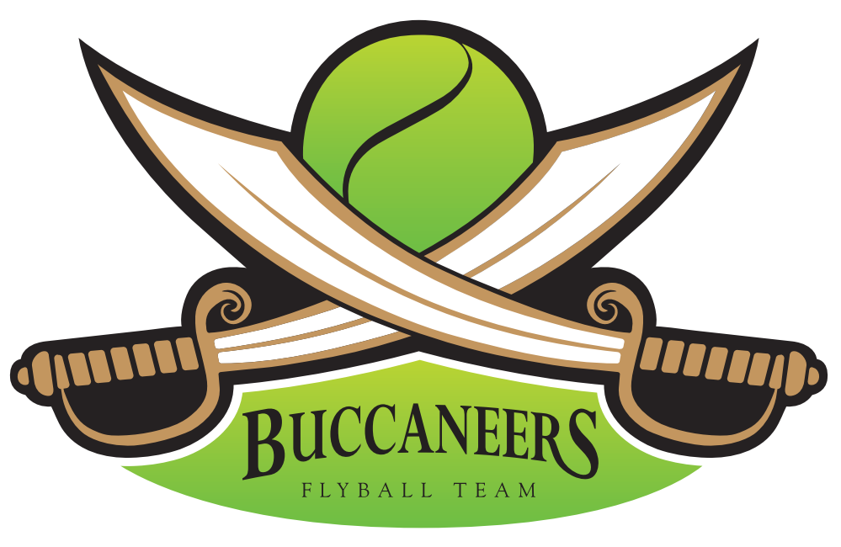

The Buccaneers invite you to a
BFA LIMITED OPEN SANCTIONED TOURNAMENT
(Limited 36 teams)
On Saturday 13th & Sunday 14th April 2024

Closing date for entries 16th March 2024
To be held at

Newbury Showground
Priors Court
Thatcham, BRK, RG18 9QZ

PLEASE NOTE: No entries can be accepted without payment. If no payment is received, then entries will be put on the reserve list with paying entries taking precedent.
Electronic entries accepted.

Please note this is just a general booking form.

For further information contact:
Katie Robinson
44 Merino Road, Andover, Hampshire, SP11 6SP
Mobile:07769 290206
Email: kitty-kat128@hotmail.com

BUCCANEERS LIMITED OPEN SANCTIONED FLYBALL TOURNAMENT
(36 teams) 13th & 14th April 2024
Closing date for entries 16th March 2024

Team Name/s | BFA Team Number
1
2
3
4
5
6

Qualified/Provisional Judges available: | Measuring Officials/Provisional Available:

Declared times must be submitted in writing (or email) at least 14 days before the tournament and must be at least 0.25 a second faster or slower than seed time.
All times, seed or declared, except Div 1, are subject to the Division break-out rule.

Team Captain:
Telephone:
E-Mail:
Address:

Team Entry @ £45 per Team
Total made payable to: Barjo Buccaneers
Payment by BACS to: Barjo Buccaneers
Sort Code: 30-93-32
Account Number: 02589304
Use team name as the reference

Please complete and return to:
Katie Robinson 44 Merino Road, Andover, Hampshire, SP11 6SP
Online Entries Accepted – Email: kitty-kat128@hotmail.com

Show Rules and Regulations

* Event organiser(s) reserve the right to refuse entries and admission to the
event of any persons not in good standing with the BFA.
*No person shall carry out punitive or harsh handling of a dog at the event.
*Bitches in season are not allowed near the show area.
*Mating of dogs is not allowed.
*A dog must be withdrawn from competition if it is:
Suffering from infectious or contagious diseases.
A danger to the safety of any person or animal.
Likely to cause suffering to the dog if it continues to compete.
*It is the Team Captains responsibility to ensure the team is available for
their division and running order.
*The organiser(s) reserve the right to make any alterations they deem
necessary in the event of unforeseen circumstances.
*All dogs are entered in the event at their owner’s risk and whilst every care
will be taken, the event organiser(s) cannot accept responsibility for damage,
injury or loss, however caused, to dog's, persons or property whilst at the
event.
*No alcohol is to be consumed within the ring.
*Smoking including vaping/electronic cigarettes is not permitted in or within
10 feet of the flyball ring during competitions.
*All owners/handlers must clean up after their dogs. Anyone failing to do so,
will be asked to leave the venue.
*BFA rules and policies will apply throughout the sanctioned tournament.
*If circumstances make it necessary for a tournament to be cancelled, the
organiser(s) reserve the right to defray expenses incurred by deducting
such expenses from the entry fees received.
*The “two-minute rule” 5.15(a) will apply throughout the tournament.
*There will be “Zero” tolerance of abusive or foul language inside the ring to either ring party, judges & other team members.

