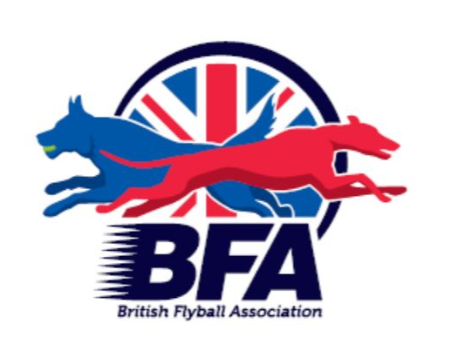

The British Flyball Association

Presents the
Regional Championships at Royal Bath and West Showground

LIMITED OPEN SANCTIONED TOURNAMENT
(60 Teams)

23rd April to 24th April 2022

(Closing date for entries 26th March 2022)
To be held at

Royal Bath and West Showground, BA4 6QN

Postal entries to:
Katie Burns, 35 Stamford Close, Macclesfield, Cheshire, SK11 7TZ

Electronic Entries (please note emailed entries will not be accepted):
https://docs.google.com/forms/d/e/1FAIpQLSdiV6q7m4ZQXrIZOGo1Co7BVi_vm4FTIX2IYFQy_IsbzMUotw/viewform

For any queries: bfachamps@gmail.com

PLEASE NOTE:
1. Postal entries will NOT be accepted without accompanying payment by cheque or postal order.
2. Electronic entries MUST be paid within 7 days of notification of successful entry - payment instructions will be sent by email.

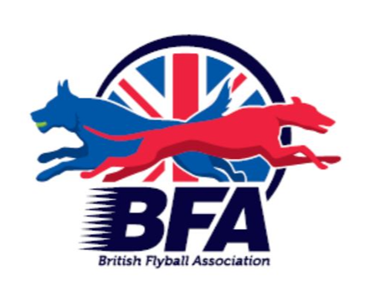

British Flyball Association Regional Championships
LIMITED OPEN SANCTIONED TOURNAMENT

Royal Bath and West Showground, BA4 6QN on 23rd and 24th April 2022
Closing date for entries 26th March 2022
Declared times must be submitted in writing (or email) at least 14 days before the Tournament and must be at least a half second slower or faster than seed time. All seed times, except Div 1, are subject to the Division break-out rule.

Team Name(s) | BFA Team Number
1
2
3
4
5
6
7
8
Team Captain

Name: | Address:
Phone Number:
E-Mail Address:

Electronic entries MUST include an email address.

Financial (No postal entries accepted without payment)

 | Price (Incl Vat) | Number | Cost
Open teams entered... | £45/team
Camping Units – covering Friday and Saturday nights | £20/unit
Total £ (cheques payable to British Flyball Association)
Payment instructions for electronic entries will be sent by email. Payment required within 7 days

SHOW RULES AND REGULATIONS

  - The tournament organiser(s) reserve the right to refuse entries and admission to any person not in good standing with the B.F.A.
  - No person shall carry out punitive or harsh handling of a dog at the tournament.
  - It is the Team Captains responsibility to ensure the Team is available for its class and running order.
  - The organiser(s) reserve the right to make any alterations they deem necessary in the event of unforeseen circumstances.
  - Bitches in season are not allowed near the show area. Mating of dogs is not allowed.
  - A dog must be withdrawn from competition if it is:
    - Suffering from any infectious or contagious disease
    - A danger to safety of any person or animal
    - Likely to cause suffering to the dog if it continues to compete
  - All dogs enter into the tournament at their own risk and whilst every care will be taken, the organiser(s) cannot accept responsibility for damage, injury or loss however caused to dogs, persons or property whilst at the event.
  - All owners/handlers must clean up after their dogs. Anyone failing to do so will be asked to leave the venue.
  - BFA rules and policies will apply throughout the sanctioned tournament.
  - No alcohol is to be consumed within or around the ring.
  - If circumstances make it necessary that the tournament is cancelled, the organisers reserve the right to defray expenses incurred by deducting such expenses from entry fees received.
  - On and around the flyball and camping fields a strict speed limit (5 mph) will apply and vehicle movement restrictions will apply throughout the event.

Entries will be taken on date of receipt as for all sanctioned tournaments: Rule A.1.3.6.

For any queries please email: bfachamps@gmail.com

A maximum of two minutes warm up will be allowed between races.

