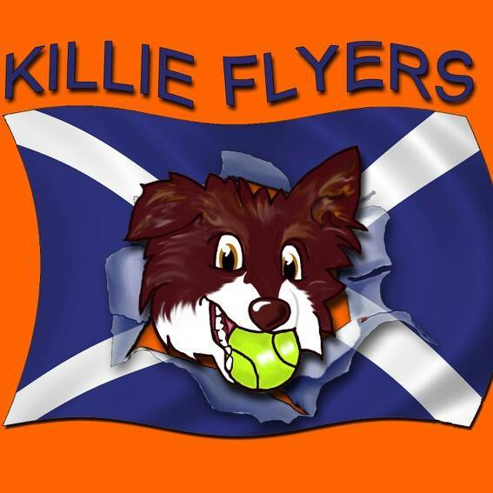

CO HOSTED WITH LOMOND FLYBALL CLUB
British Flyball Association
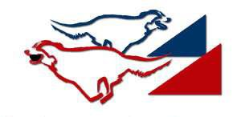

Sanctioned
Limited Open Tournament
(54 Teams)
At
Hartfield Farm, Paisley,
Renfrewshire, Scotland, PA2 8UU.

26th & 27th MAY 2018
(Closing Date 30th April 2018)

Entries to: Alison Hunter
34 Meiklewood Road
Kilmarnock
East Ayrshire
KA3 2BU
For Further information please contact

Alison Hunter
Mobile: 07591854095
Email: Allysk9z@sky.com

Killie Flyers
CO HOSTED WITH LOMOND FLYBALL CLUB

Directions to:- Hartfield Farm, Paisley, Scotland, PA2 8UU.

M8 towards Glasgow Airport/Greenock
At junction 28A, exit onto A737 towards Irvine
Take the B787 exit towards Kilbarchan
At the roundabout, take the 1st exit onto Kilbarchan Rd/B787
At the roundabout, take the 2nd exit onto Cochranemill Rd/B787
At the roundabout, take the 2nd exit onto Beith Rd/B787
Turn left onto Auchengreoch Rd
Turn right
Turn right
Turn right
Turn right
Destination will be on the right and will be well sign posted for Hartfield Farm Entrance
Satnav will take you to the Farmhouse & Kennels so please follow Flyball Signs

Show rules and regulations

- The tournament organisers reserve the right to refuse entries and admission to any person not in good standing with the BFA.
- No person shall impugn the decisions of the Head Judge or Judges.
- Bitches in season are not allowed near the show area, mating of dogs is not allowed.
- It is the Team Captains responsibility to ensure the team is available for their class and running order.
- The organisers reserve the right to make any alterations they deem necessary in event of unforeseen circumstances.
- All dogs are entered in this event at their owners risk and, whilst every care will be taken, the event organisers cannot accept responsibility for damage, injury or loss however caused to dogs, persons or property whilst at the event.
- A dog must be withdrawn from competition if it is:
- Suffering from infectious or contagious diseases;
- A danger to the safety of any person or animal; or
- Likely to cause suffering to the dog if it continues to compete.
- All owners/handlers must clean up after their dogs. Anyone failing to do so will be asked to leave the venue.
- If circumstances make it necessary that the tournament is cancelled, the organisers reserve the right to defray expenses incurred by deducting such expenses from entry fees received.
- Current BFA Rules and Policies will apply throughout the Sanctioned Tournament.

THANK YOU

Killie Flyers
CO HOSTED WITH LOMOND FLYBALL CLUB

Entry Form for BFA Sanctioned Limited Open Tournament
(Limited to 54 Teams)

Hartfield Farm, Paisley,
Renfrewshire, Scotland, PA2 8UU.

26th & 27th MAY 2018
(Closing Date 30th April 2018)
Entry fee £40 per Team

Declared times must be submitted in writing (or email) at Least 14 days before the tournament and must be at least half a second faster or slower than seed time. (BFA rule 4.4) Team break out time is half a second faster than declared time (BFA rule 5.17(I))
All times, seed or declared, except Div 1, are subject to the division break out rule.

 | Team Name | BFA No
1
2
3
4
5
6

Team Captain
Address:
BFA No.
Tel No:
Email:

If you are able to provide a judge for our show, please indicate this below.
Provisional Judge:- Qualified Judge:-

See over for Starters Entry and information about camping requirements.
Killie Flyers
CO HOSTED WITH LOMOND FLYBALL CLUB

Starters Competition Entry Form

26th & 27th MAY 2018
(Closing Date: 30th April 2018)

Entry fee £25 per Starters Team

Starters Team Name
1
2
3
4
5
6

Show Details & information
• The show will be run outdoors on grass
- RR Block
- Chewing the fat catering van available on site plus
- Co-hosted with Lomond Flyball Club
- Water will be available for dogs & caravans Only….PLEASE BRING OWN DRINKING WATER

Killie Flyers
CO HOSTED WITH LOMOND FLYBALL CLUB

FINANCIAL INFORMATION AND CAMPING BOOKING

Camping  @ £8 per unit per night. | Number of  caravans | Number of tents | Total
Friday
Saturday
Sunday

Camping MUST be paid for in advance & available from 2pm on Friday.

 |  | Total to pay
 | Number of camping units……………..@ £8 per night | £
 | Number of Open Teams entered @ £40 per team | £
 | Number of Starters Teams entered @ £25 per team | £
 | Overall Total | £

Cheque enclosed for £ (Cheques payable to KILLIE FLYERS)

Bank Transfer Details: Bank Of Scotland, Sort Code 80-22-60, A/C 15646462

(Please supply email for tournament info & running orders)

If you fail to gain entry due to oversubscription refund of electronic fees
will be honored.

Thank you for your entry and we look forward to welcoming you to our show & our new venue.

