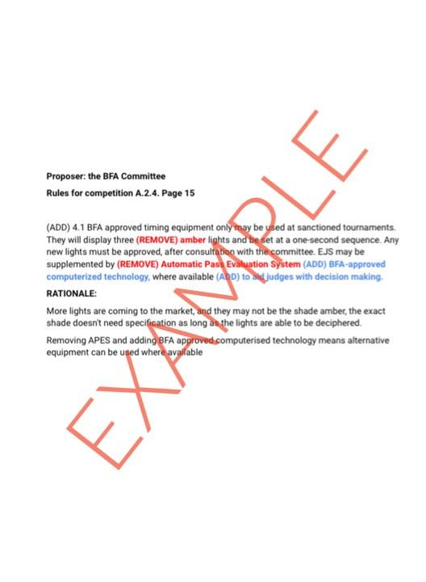

PROPOSERS NAME & BFA NUMBER

RULE NUMBER the proposer wants to change, section, and page number :

RULE CONTENT ( please put in red which part you would like to remove and in blue which part you would like to add)

RATIONALE:

