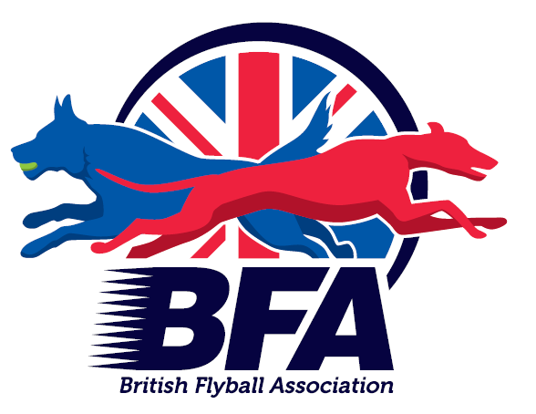
Insert Team
COVID-19 Training Plan
Insert Team Name will be re-introducing training with adaptions, considering current government guidance regarding social distancing and permitted numbers in groups. This document outlines the new restrictions to be implemented at training to reduce the spread of COVID-19 and safeguard your health, and the wellbeing of all our members.

It is important to understand that even when people appear not to have symptoms of coronavirus (COVID-19), they may still be carrying the virus. Meeting people from outside of your own household can increase your risk of catching the virus, depending on the situation. Please consider the greater risks posed to those who are classed as vulnerable who you may meet outside of flyball training.

All risks should be considered and assessed by each individual when they are considering returning to flyball training sessions.

A full risk assessment has taken place by to evidence how Insert Team Name will adhere to government guidance. This will be available Team to decide where members will access. The BFA recommends to review and update this guidance each time the Government changes your Team’s geographical specific guidance.

COVID-19 restrictions for Insert Team Name training:

- Any team member(s) with symptoms of coronavirus, or who have been told self-isolate because they, or a member of their household, have symptoms or have tested positive for coronavirus (COVID-19), shall not leave their home or attend the training session.
- Only 6 people, including trainers, will attend each training session. Members who have not been invited to the training session and turn up to training will be asked to leave.
- All training will take place outside.
- The gates to the venue will remain open at all times.
- All members should avoid touching the gates and fencing at the venue.
- Members that turn up early to their training session shall remain in their vehicle until the trainer indicates they can leave their vehicle. Failure to follow instructions may lead to being asked to leave the venue.
- All members MUST social distance (minimum 2 metres) from other members, who are not from the same household, at ALL times. Members not adhering to social distancing will be asked to leave.
- Members shall not touch dogs from another household.
- Hand sanitiser shall be applied by all attending members at the beginning, the end and, when necessary, during the training session. Members are encouraged to bring their own hand sanitiser, though Insert Team Name will also have some available.
- PPE (gloves) will be available if members feel more comfortable wearing these, If members wish to wear a face mask/covering these shall be provided by the member.
- A maximum of THREE people will set up the flyball equipment at the beginning of the training session. These same three members will be the only ones who move/adjust training equipment, excluding boxes which will be handled by boxloaders wearing gloves.
- All equipment will be deep cleaned and sanitised before and after each training session.
- All jumps and boxes will be cleaned for a change of dog from a different household. Where possible dogs from the same household will be trained in the same lane, on the same box, unless dogs require different equipment.
- Each member shall have their own balls. Members who do not have their own supply will be provided with club balls and they will then be responsible for washing these and bringing them to subsequent training sessions. If members do not bring their balls to training they will be unable to train.
- Only two dogs will be trained at the same time.
- Boxloaders shall wear gloves. Gloves shall be changed between dogs if the dogs are from different households. Hand sanitiser shall also be used.
- There will be no communal refreshments provided.
- There will be no communal water bowls for dogs. Dogs shall be provided with water/hydration at their owner’s vehicles only.
- All rubbish should be taken home. There will be a bin provided for disposal of gloves/wipes used for training purposes.
- Members not adhering to these conditions will be asked to leave.

By attending training members of Insert Team Name are accepting and agreeing to follow the conditions outlined in this document. Please read and sign below -

• I can confirm I have READ and I will ADHERE to the above restrictions whilst training with
the Team.
• I will NOT attend training if I develop any COVID-19 symptoms.
• I will be attending training at my own risk and understand that meeting people outside of
my household will increase the chance of developing COVID-19 symptoms.
• Are NOT responsible for my health if I were to develop COVID-19
Symptoms.

Name ...............................................................

Sign ...............................................................

Date ...............................................................

