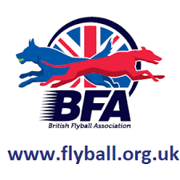

**Unrestricted Flyball – Date TBC**

Return to more traditional format of flyball comps.

Progression to Stage 5 can only happen with the removal of all national social distancing measures.

**COVID-19 Adapted Flyball 1 September – TBC**

BFA Action Plan and Risk Assessment agreed for commencement of organised adapted flyball activities.

Flyball Foundation training and racing incorporating social distancing and hygiene measures; risks of droplet and fomite tramsmission appropriately mitigated. Track & Trace enabled. COVID Code of Behaviour published.

**National Lockdown 23 March – 13 May**

Training at home.

Chute work, targeted training.

Fitness within daily exercise limits.

**Easing of Lockdown Restrictions 13 May – 4 July**

Training within household groups outdoors.

Increased opportunity for fitness and conditioning training.

**Small Group Training 4 July – 1 September**

Team training, in small groups (6 people or 2 households), and in accordance with government and BFA Return to Flyball guidance (published on Social Media) and on completion of training COVID Risk Assessment. Focus on preparation for return to comps.

**BFA Committee Statement**:

The British Flyball Association is committed to the safety and welfare of our members and their dogs, and we will carefully manage the return of competitive flyball with safety as our top priority.

We will continue to be led by UK Government’s advice and will update our guidance depending on how the national COVID-19 situation develops.

**BFA Roadmap for the Return of Competitive Flyball**

STEP **2**

STEP **3**

STEP **4**

STEP **1**

STEP **5**