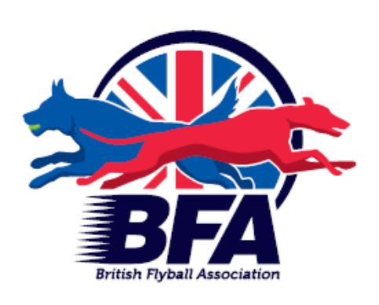

**British Flyball Association**

**C.4 Record Report Form**

This form needs to be filled out when a record time is run and the official report of the formalities performed for verifying of the record by the British Flyball Association (BFA)

There must be two neutral qualified officials available at the tournament (a second head judge, committee member or qualified judge, in that order of preference).

**The Records and Statistics Team must receive this document within 7 days of the tournament (this can be scanned and emailed to bfastats@gmail.com)**

Date: Event: Venue:

|  |  |  |
| --- | --- | --- |
|  | Race No: |  |

Division:

Surface:

Class of Competition: (Tick one)

|  |  |  |  |
| --- | --- | --- | --- |
| Open |  | Multibreed |  |

|  |  |  |  |
| --- | --- | --- | --- |
| Head Judge: |  | Tournament Organiser: |  |

**RECORD TIME:**

: seconds

|  |  |  |  |
| --- | --- | --- | --- |
| Team Name: |  | Team Captain: |  |

|  |  |  |  |
| --- | --- | --- | --- |
| Jump Height Set at: |  | Box Loader: |  |

|  |  |  |  |  |  |  |  |  |  |  |  |  |  |  |  |
| --- | --- | --- | --- | --- | --- | --- | --- | --- | --- | --- | --- | --- | --- | --- | --- |
|  | **Dog** | **Dogs BFA No** | | | | | | **Breed** | **Jump Height** | **Handler** | **Handlers BFA No.** | | | | |
| **1** |  |  |  |  |  |  |  |  |  |  |  |  |  |  |  |
| **2** |  |  |  |  |  |  |  |  |  |  |  |  |  |  |  |
| **3** |  |  |  |  |  |  |  |  |  |  |  |  |  |  |  |
| **4** |  |  |  |  |  |  |  |  |  |  |  |  |  |  |  |

Check list of actions performed by the Head Judge to verify the record:

**Measure the course to verify that it is set correctly.**

* Length and layout
* Jump height of all four jumps
* BFA Approved Timing System functions correctly on the Start/Finish line
* Throw of all sizes of balls used from all holes (each hole to be checked four times)
* Box dimensions

Head Judges declaration:

I as Head Judge verify that the checked items all meet BFA Regulations.

Signature: Date:

2nd Official declaration:

I As 2nd Head Judge/Committee Member/Qualified Judge *(cross out what doesn’t apply),* verify that this form is completed correctly.

Signature: Date:

We do hereby certify that the electronic judging system shows no errors or faults, and hereby declare a new official

**British Flyball** record.

**BFA official checks**

* Dog height (using C9 or master list)
* Age of competing dogs
* All handlers are current BFA members
* Dogs are all registered to current BFA members